**RAJALAKSHMI ENGINEERING COLLEGE**

**RAJALAKSHMI NAGAR,THANDALAM–602105**

**(REGULATION 2023)**

**CS23432**

**DEPARTMENT OF ARTIFICIAL INTELLIGENCE AND MACHINE LEARNING**

**LABORATORY RECORD NOTEBOOK**

ASHWADH

2/AIML/FA

2116231501022

4

2024-2025

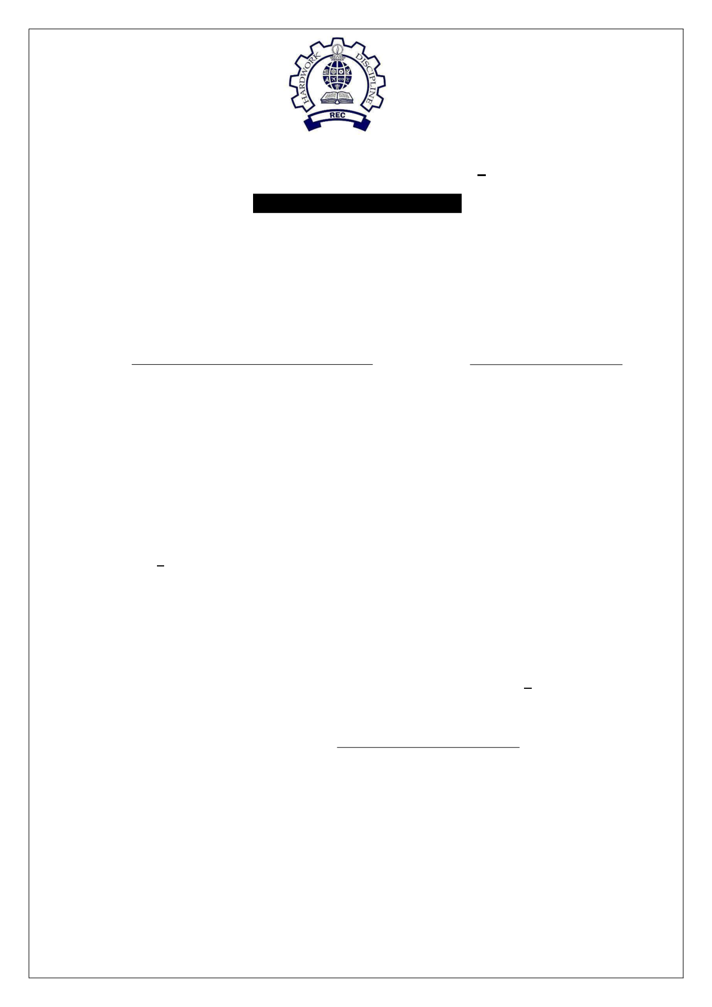

**RAJALAKSHMI ENGINEERING COLLEGE (AUTONOMOUS)**

**RAJALAKSHMI NAGAR, THANDALAM 602 105**

**BONAFIDE CERTIFICATE**

|  |  |  |  |
| --- | --- | --- | --- |
| NAME | ASHWADH | REGISTER NO. | **2116 231501022** |

ACADEMIC YEAR 2024-25 **SEMESTER**- IV **BRANCH**: AIML-B.Tech

This Certification is the Bonafide record of work done by the above student

in the **CS23432**- **Software Construction** Laboratory during

the year 2024 2025.

Signature of Faculty -in Charge

Submitted for the Practical Examination held on

Internal Examiner External Examiner

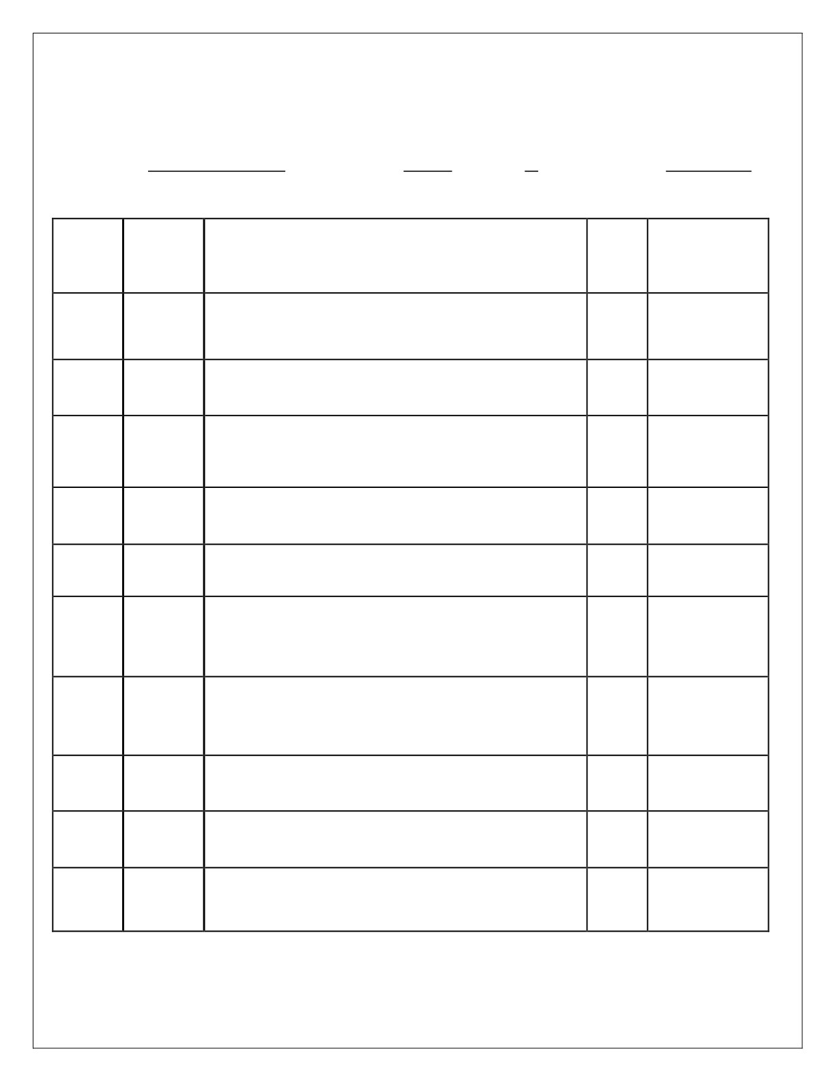

**INDEX**

**NAME:** ASHWADH **BRANCH:** AIML **SEC:** A **ROLL NO:** 231501022

|  |  |  |  |  |
| --- | --- | --- | --- | --- |
| s.  **No.** | **Date** | **TITLE** | **Page**  **No.** | **Teacher's Signature**  **/**  **Remarks** |
| **1.** | 31.1.25 | Azure DevOps Environment Setup |

|  |  |
| --- | --- |
| **2.** | 14.2.25 Azure DevOps Project Setup and User Story Management |

|  |  |
| --- | --- |
| **3.** | 21.2.25 Setting Up Epics, Features, and User Stories for Project Planning |

**4.**  28.2.25 Sprint Planning

**5.**  31.1.25 Poker Estimation

|  |  |
| --- | --- |
| **6.** | 07.3.25 Designing Class and Sequence Diagrams for Project Architecture |

|  |  |
| --- | --- |
| **7.** | 21.2.25 Designing Architectural and ER Diagrams for Project Structure |

**8.**  28.3.25 Testing – Test Plans and Test Cases

**9.**  04.4.25 Load Testing and Performance Testing

**10.**  21.4.25 Github: Project Structure & Naming Conventions

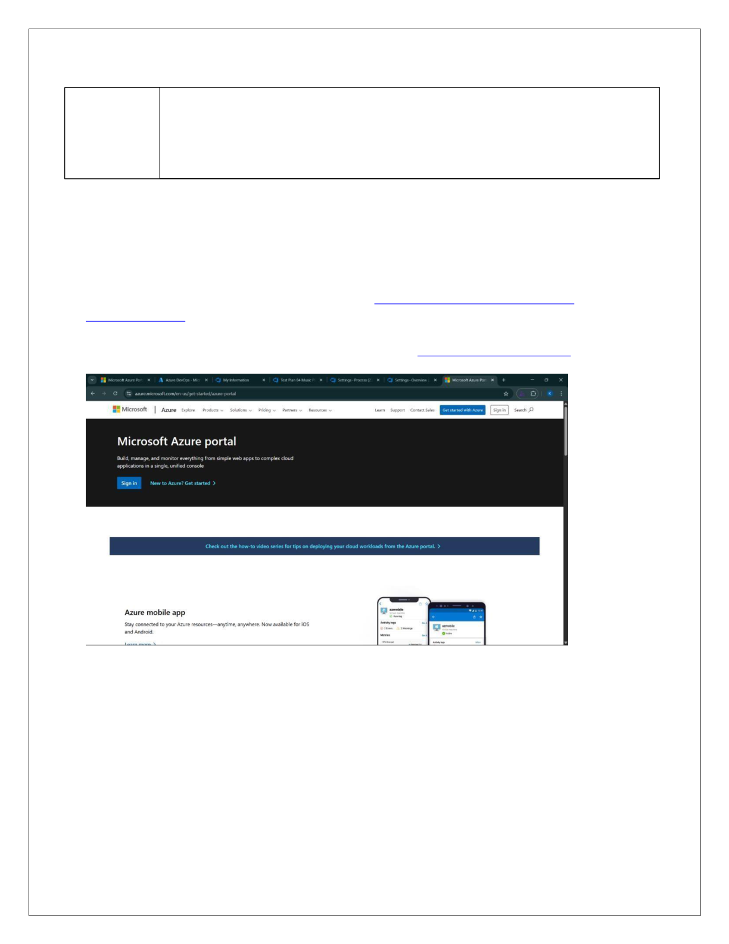

**EXP NO: 1** Create Epic, Features, User Stories, Task **AZURE DEVOPS ENVIRONMENT SETUP**

**Aim:**   
 To set up and access the Azure DevOps environment by creating an organization through the Azure portal.

**INSTALLATION**

1.Open your web browser and go to the Azure website: [https://azure.microsoft.com/en-us/get- started/azure-portal.](https://azure.microsoft.com/en-us/get-started/azure-portal)

Sign in using your Microsoft account credentials.

If you don't have a Microsoft account, you can create one here: <https://signup.live.com/?lic=1>

2116231501032 CS23432

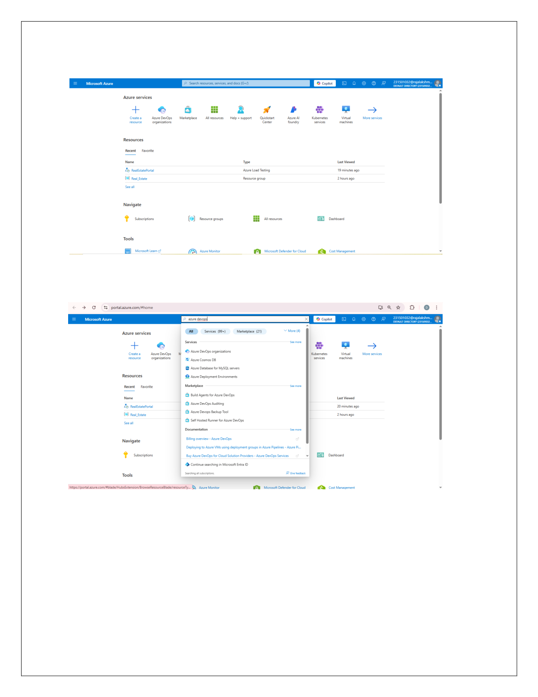

2.Azure home page

3.Open DevOps environment in the Azure platform by typing ***Azure DevOps Organizations*** in the search bar.

4.Click on the ***My Azure DevOps Organization*** link and create an organization and you should be taken to the Azure DevOps Organization Home page.

2116231501032 CS23432

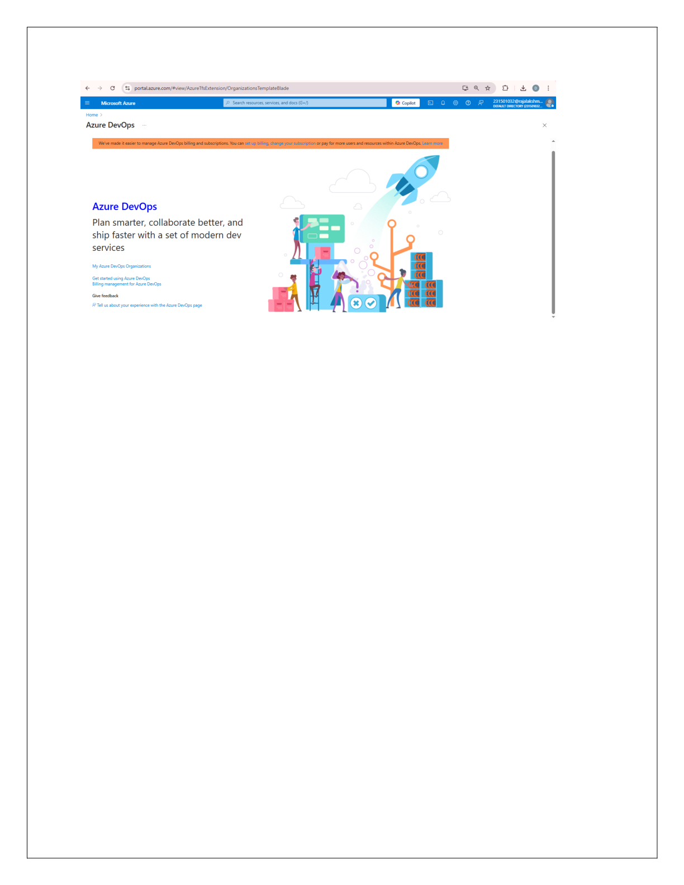

**Result:**   
 Successfully accessed the Azure DevOps environment and created a new organization through the Azure portal.

2116231501032 CS23432

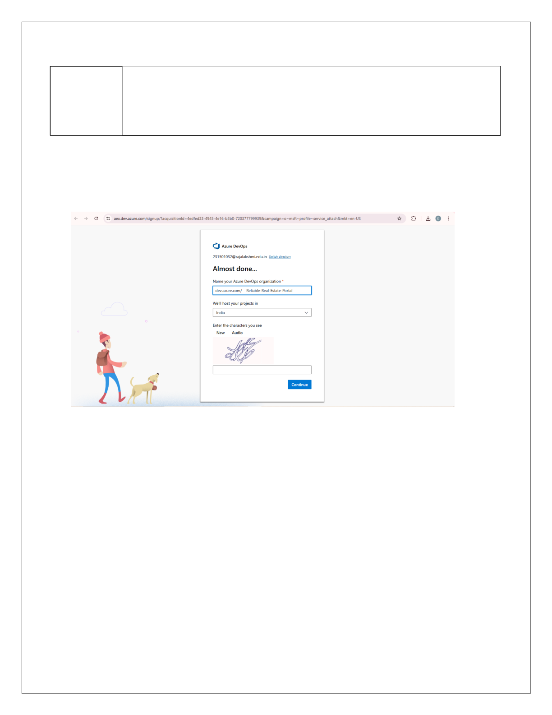

**EXP NO: 2** Create Epic, Features, User Stories, Task **AZURE DEVOPS PROJECT SETUP AND USER STORY**

**MANAGEMENT**

**Aim:**   
 To set up an Azure DevOps project for efficient collaboration and agile work management.

1.Create An Azure Account

2.Create the First Project in Your Organization   
 a.After the organization is set up, you’ll need to create your first **project**. This is where you'll

begin to manage code, pipelines, work items, and more.

b.On the organization’s **Home page**, click on the **New Project** button.

c.Enter the project name, description, and visibility options: ***Name****:* Choose a name for the project (e.g., LMS).

***Description****:* Optionally, add a description to provide more context about the project. ***Visibility****:* Choose whether you want the project to be **Private** (accessible only to those invited) or **Public** (accessible to anyone).

d.Once you’ve filled out the details, click **Create** to set up your first project.

2116231501032 CS23432

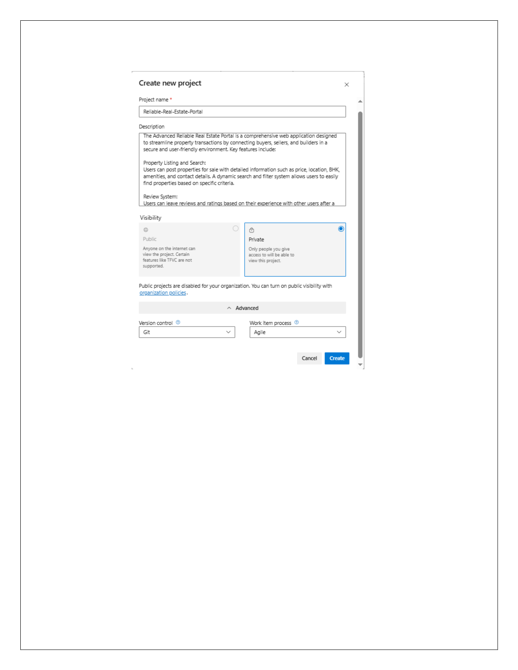

3.Once logged in, ensure you are in the correct organization. If you're part of multiple organizations, you can switch between them from the top left corner (next to your user profile). Click on the Organization name, and you should be taken to the Azure DevOps Organization Home page.

2116231501032 CS23432

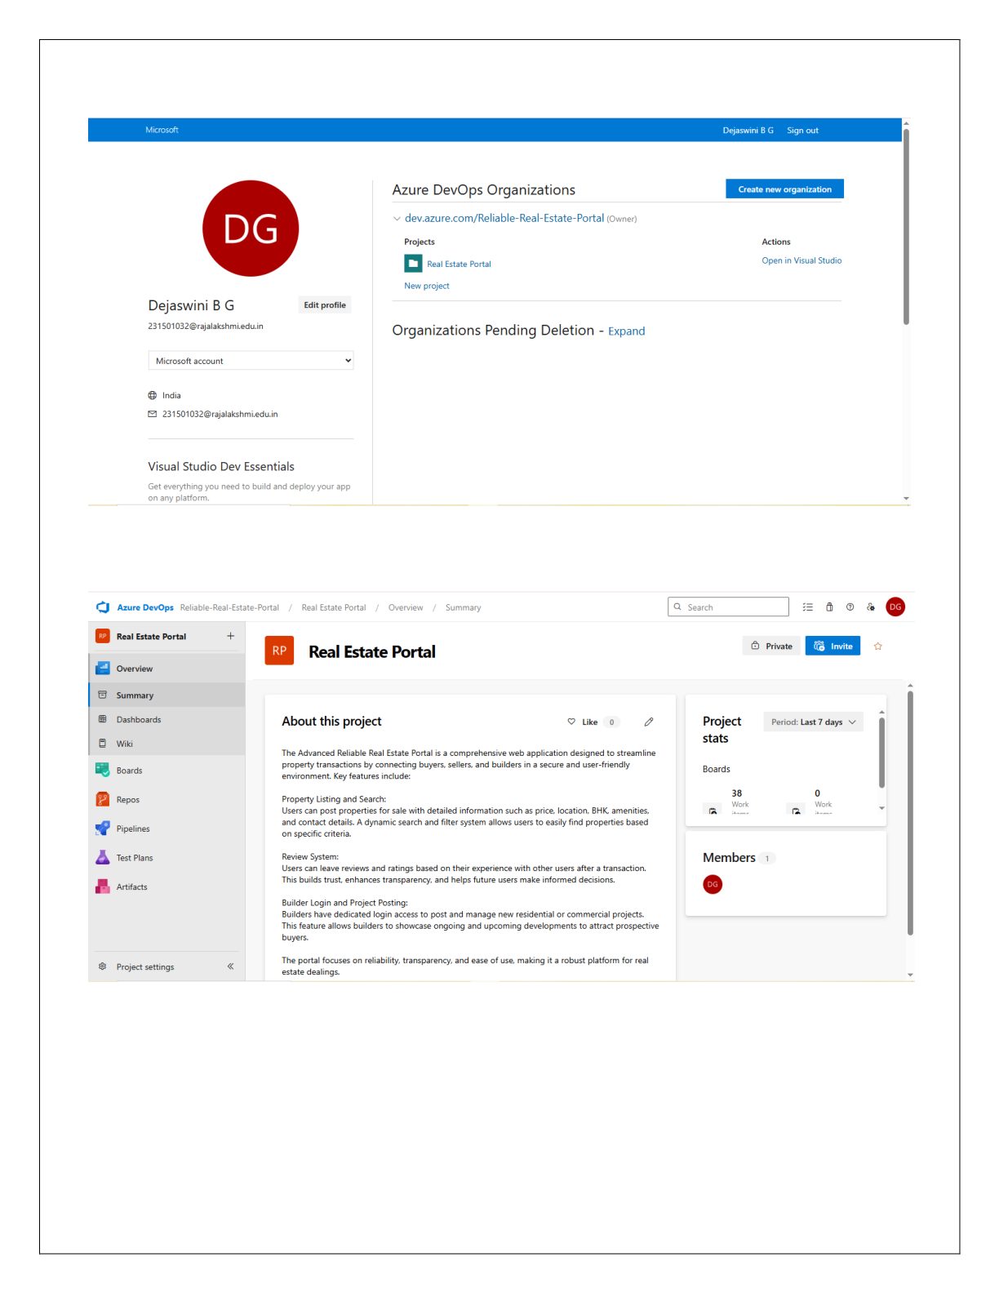

4.Project dashboard

2116231501032 CS23432

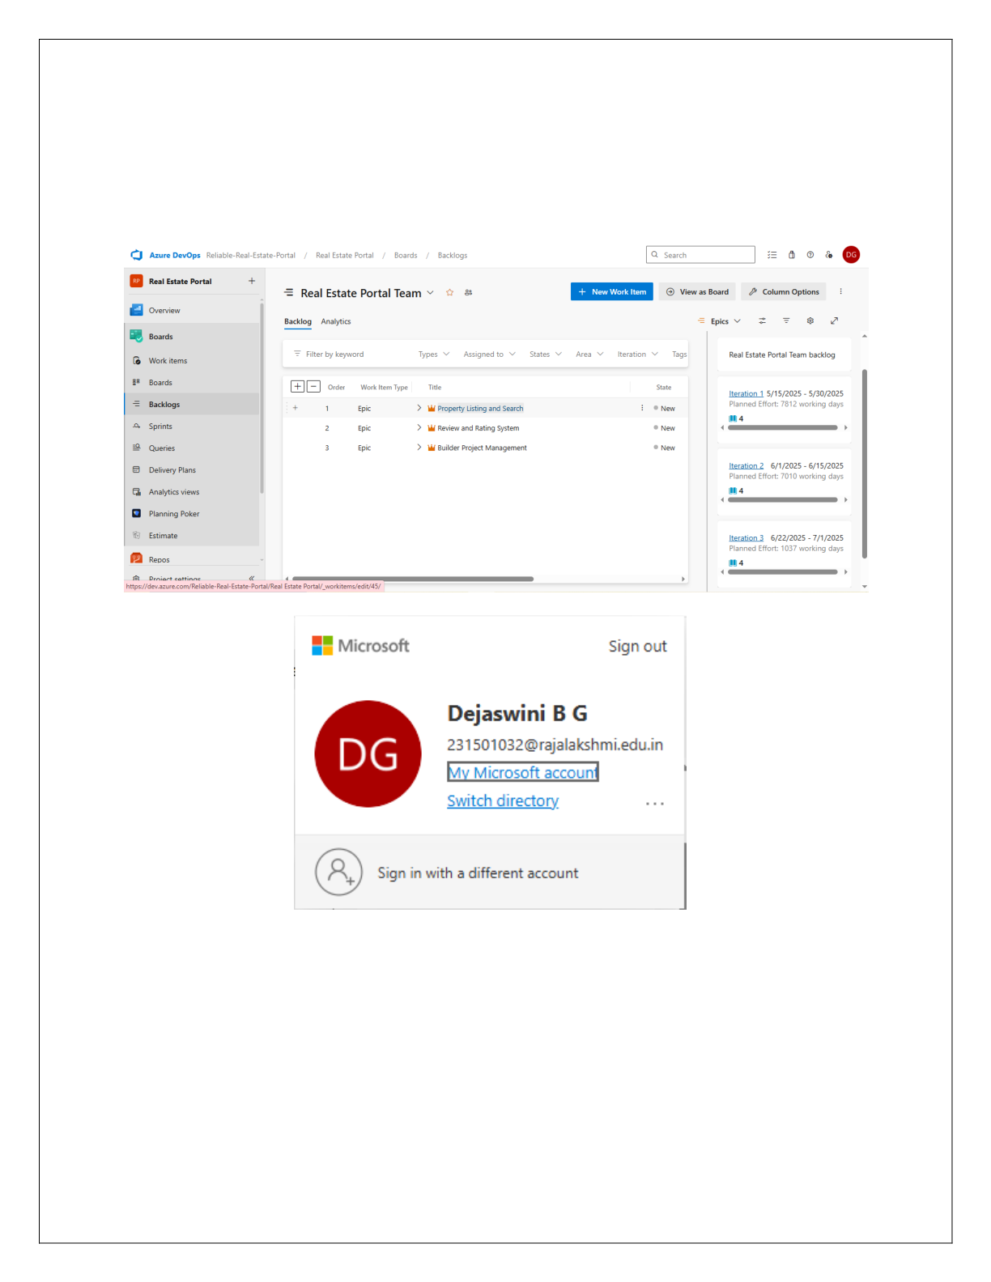

5.To manage user stories:   
 a.From the **left-hand navigation menu**, click on **Boards**. This will take you to the main **Boards** page, where you can manage work items, backlogs, and sprints.

b.On the **work items** page, you'll see the option to **Add a work item** at the top. Alternatively, you can find a **+** button or **Add New Work Item** depending on the view you're in. From the **Add a work item** dropdown, select **User Story**. This will open a form to enter details for the new User Story.

2116231501032 CS23432



|  |  |
| --- | --- |
| **Result:**  setup. | Successfully created an Azure DevOps project with user story management and agile workflow |

2116231501032 CS23432

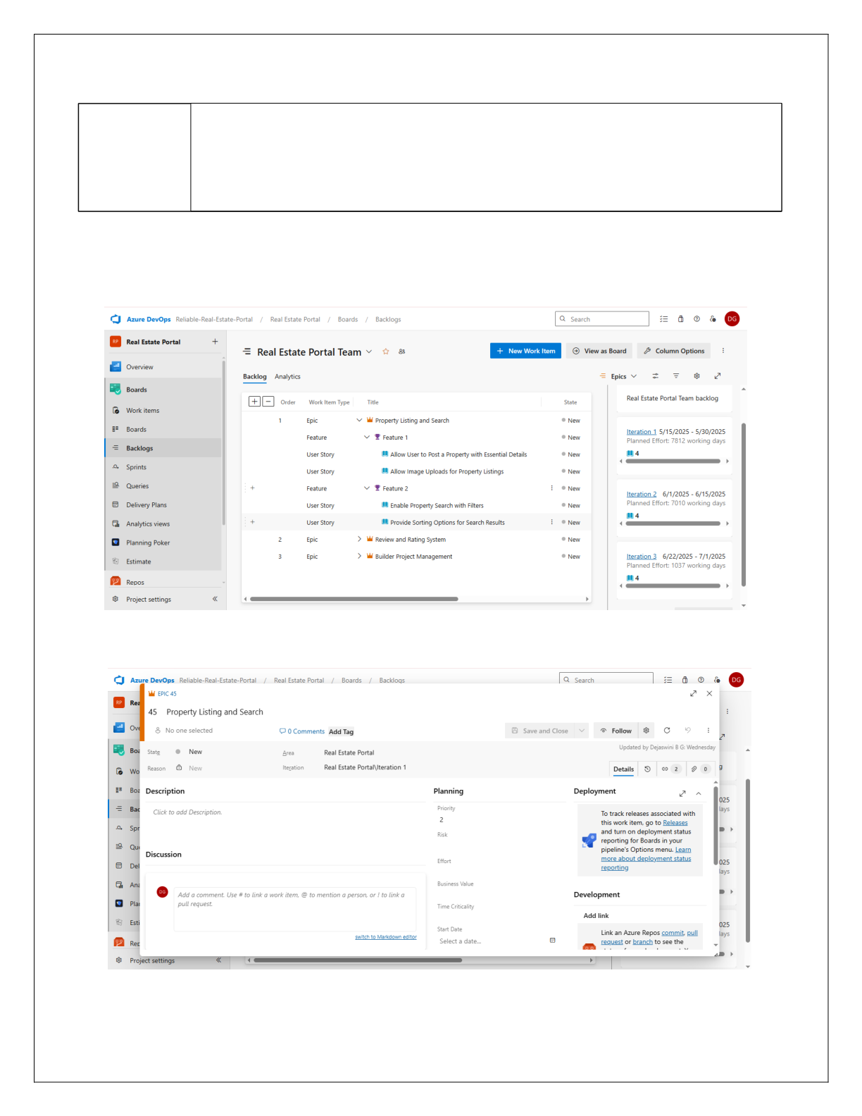

**EXP NO: 3** Create Epic, Features, User Stories, Task **SETTING UP EPICS, FEATURES, AND USER STORIES**

**FOR PROJECT PLANNING**

**Aim:**

To learn about how to create epics, user story, features, backlogs for your assigned project.

**Create Epic, Features, User Stories, Task**

**1.Fill in Epics**

2116231501032 CS23432

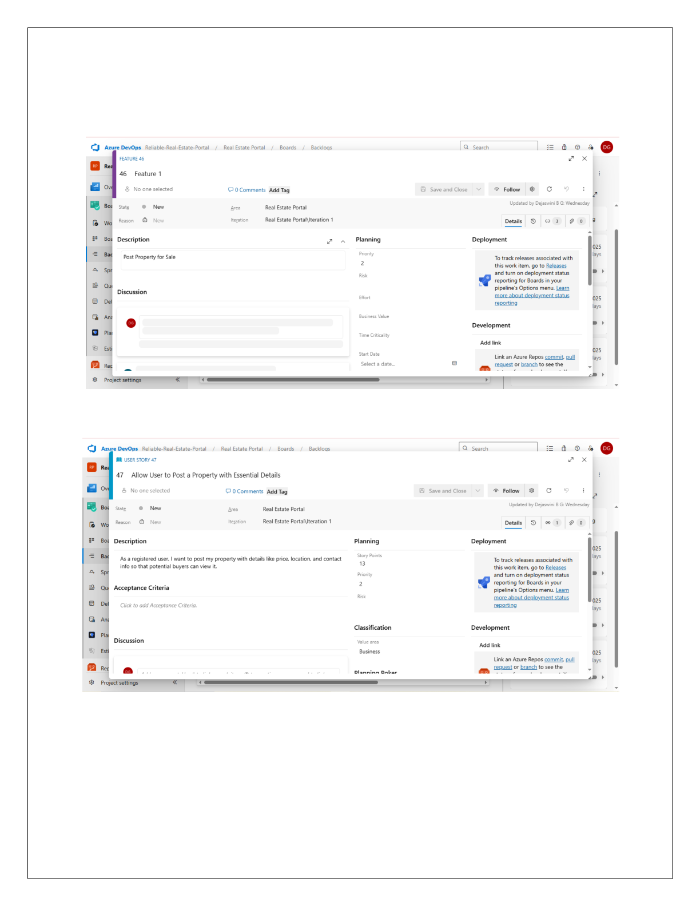

**2.Fill in Features**

**3.Fill in User Story Details**

2116231501032 CS23432



**Result:**   
 Thus, the creation of epics, features, user story and task has been created successfully.

2116231501032 CS23432

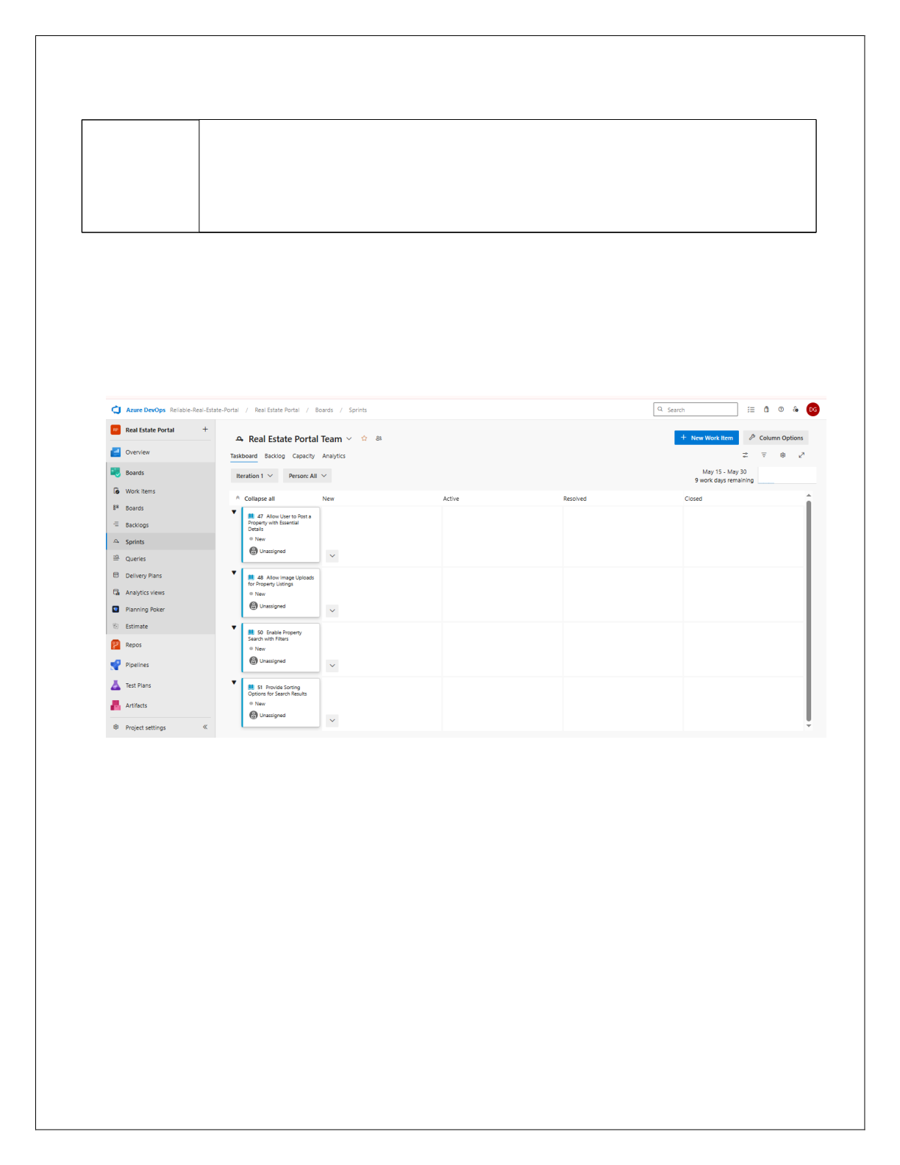

|  |  |
| --- | --- |
| **EXP NO: 4** Create Epic, Features, User Stories, Task | **SPRINT PLANNING** |

**Aim:**   
 To assign user story to specific sprint for the Online Banking System Project.

**Sprint Planning**   
**Sprint 1**

2116231501032 CS23432

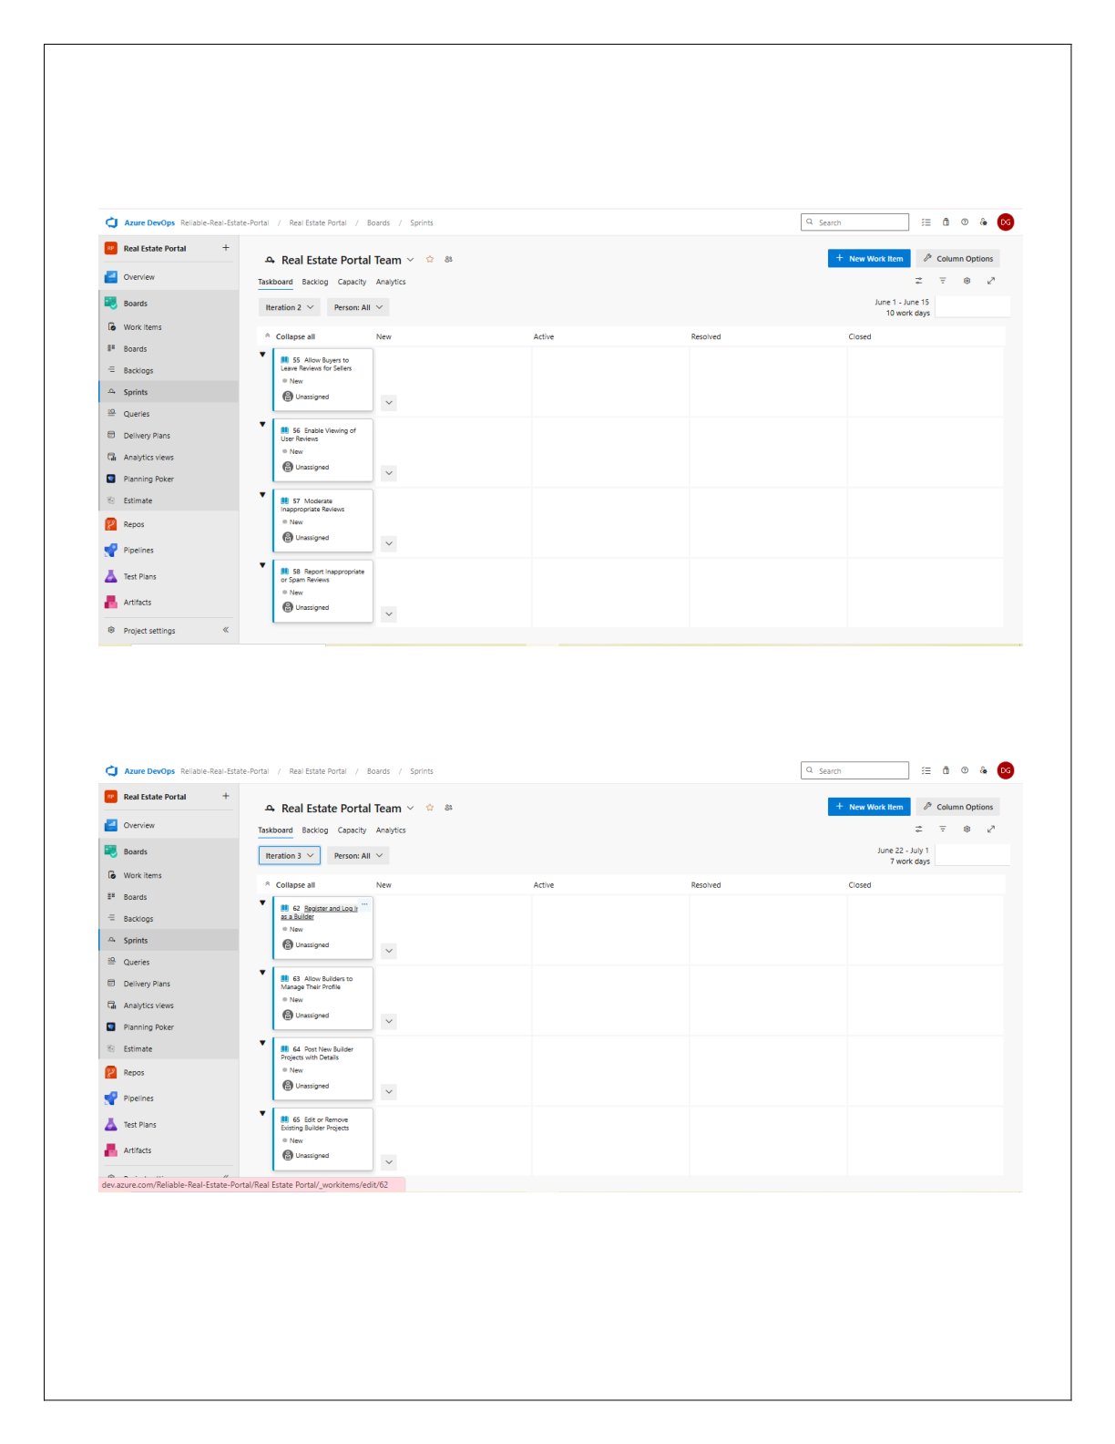

**Sprint 2**

**Sprint 3**

2116231501032 CS23432



**Result:**   
 The Sprints are created for the Online Banking System Project.

2116231501032 CS23432

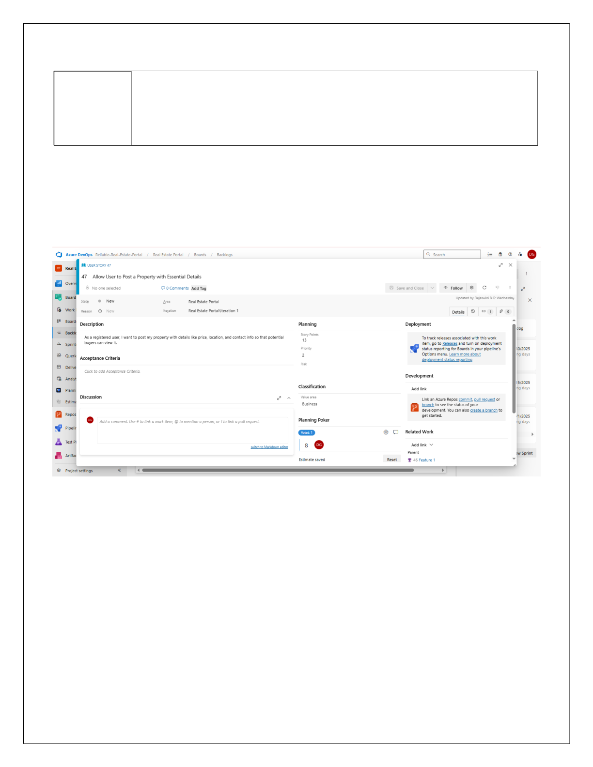

**EXP NO: 5** Create Epic, Features, User Stories, Task **POKER ESTIMATION**

**Aim:**   
 Create Poker Estimation for the user stories - Online Banking System Project.

**Poker Estimation**

**Result:**   
 The Estimation/Story Points is created for the project using Poker Estimation.

2116231501032 CS23432

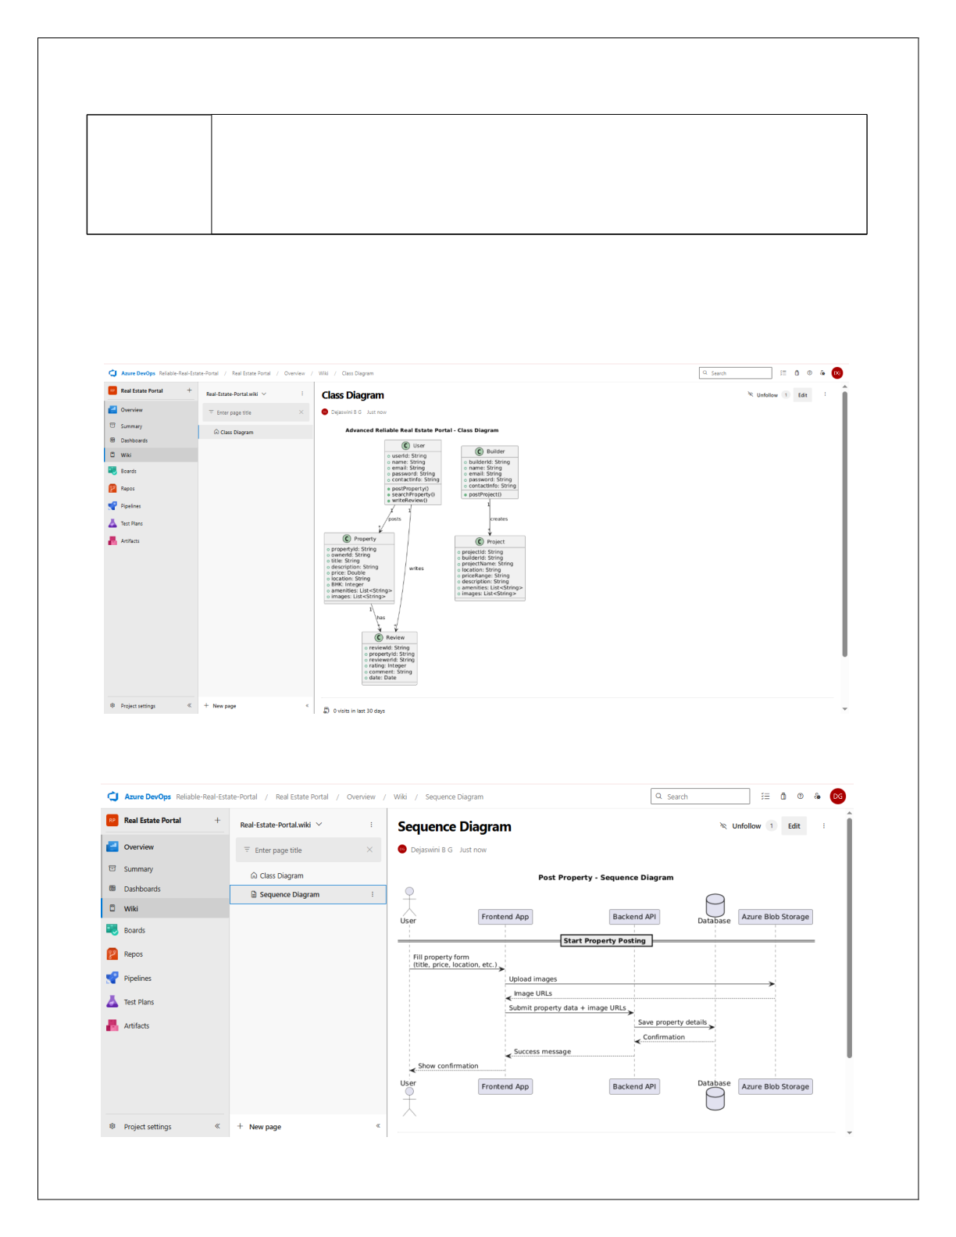

**EXP NO: 6** Create Epic, Features, User Stories, Task **DESIGNING CLASS AND SEQUENCE DIAGRAMS FOR**

**PROJECT ARCHITECTURE**

**Aim:**

To Design a Class Diagram and Sequence Diagram for the given Project.

**6A. Class Diagram**

**6B. Sequence Diagram**

2116231501032 CS23432



**Result:**   
 The Class Diagram and Sequence Diagram is designed Successfully for the Online Banking System.

2116231501032 CS23432

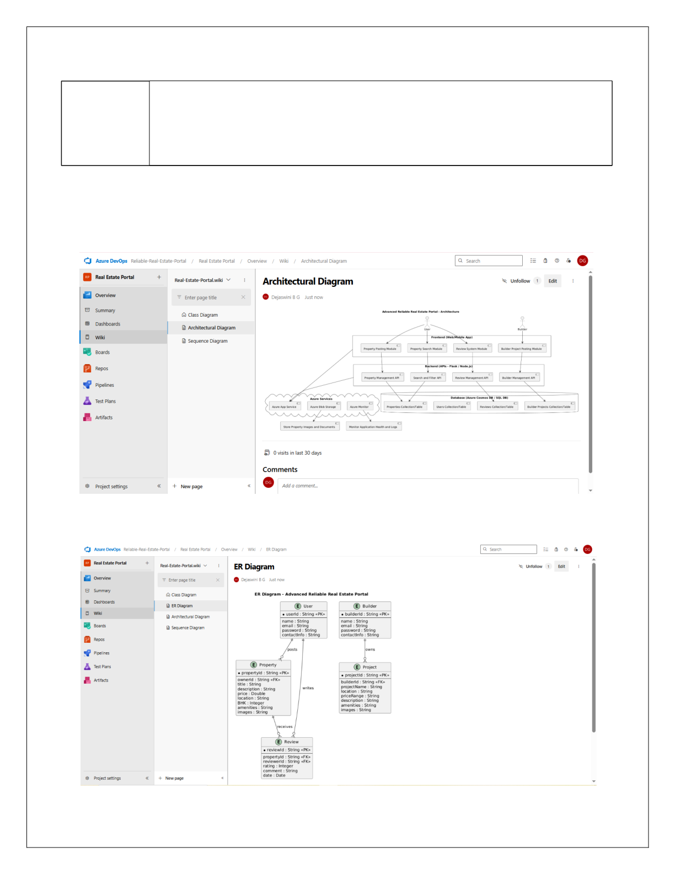

|  |  |
| --- | --- |
| **EXP NO: 7** | **DESIGNING ARCHITECTURAL AND ER DIAGRAMS FOR PROJECT STRUCTURE** |

**Aim:**

To Design an Architectural Diagram and ER Diagram for the given Project.

**7A. Architectural Diagram**

**7B.ER Diagram**

2116231501032 CS23432



**Result:**   
 The Architecture Diagram and ER Diagram is designed Successfully for the Online Banking System.

2116231501032 CS23432

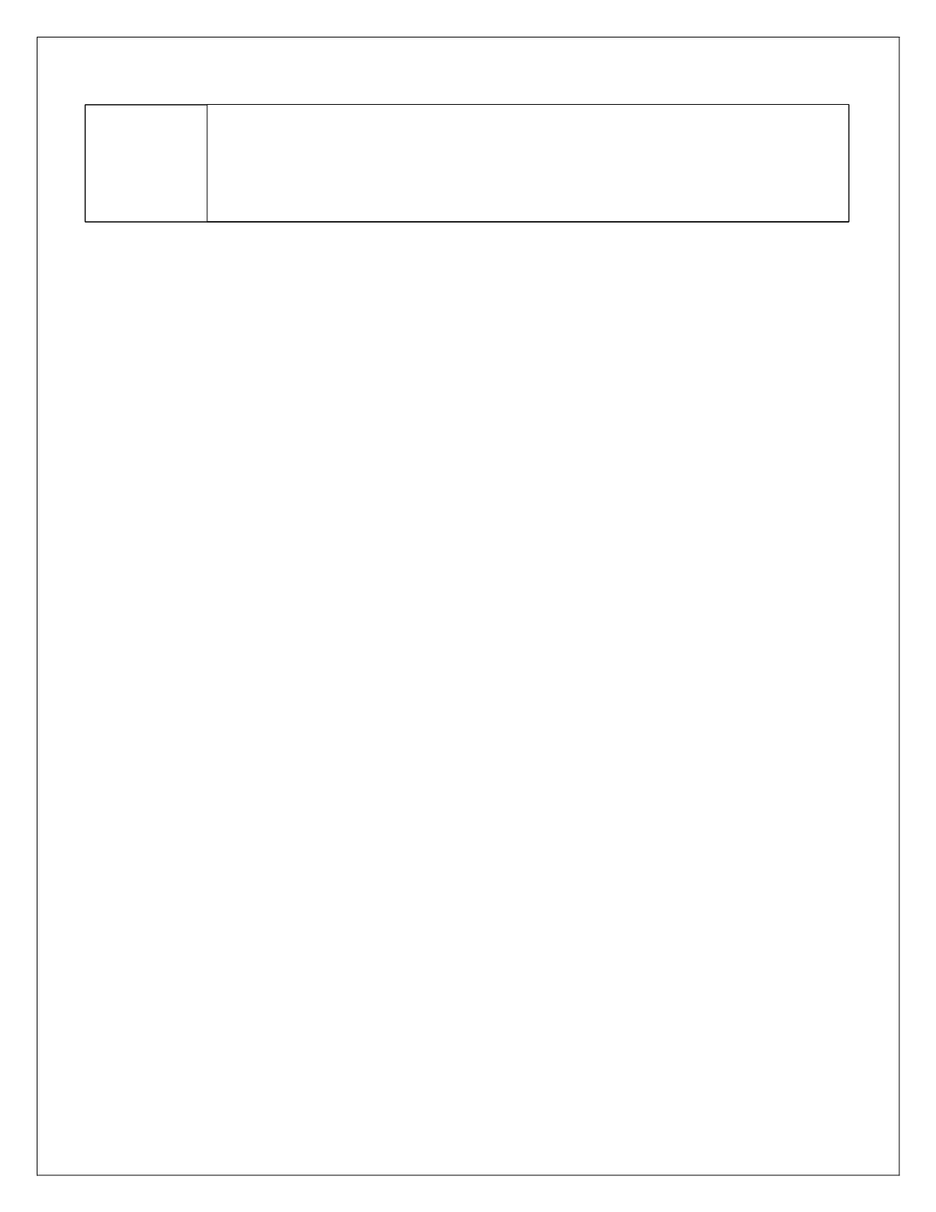

**EXP NO: 8**  **TESTING – TEST PLANS AND TEST CASES**

Create Epic, Features, User Stories, Task

**Aim:**

Test Plans and Test Case and write two test cases for at least five user stories showcasing the happy path and error scenarios in azure DevOps platform.

**Test Planning and Test Case**

**Test Case Design Procedure**

1.**Understand Core Features of the Application**

oProperty Posting   
oProperty Search & Filter   
oUser Reviews   
oBuilder Login & Registration   
oBuilder Project Posting

2.**Define User Interactions**

oTest cases simulate actual user behavior (e.g., posting properties, filtering listings, submitting reviews)

3.**Design Happy Path Test Cases**   
 oVerify that each feature works as expected under normal conditions.

4.**Design Error Path Test Cases**   
 oSimulate unexpected/invalid scenarios to test robustness.

5.**Break Down Steps and Expected Results**   
 oEach test case includes step-by-step actions and the expected outcome.

6.**Use Clear Naming and IDs**   
 oTest cases are named clearly (e.g., Successful Login, Missing Required Fields).

2116231501032 CS23432

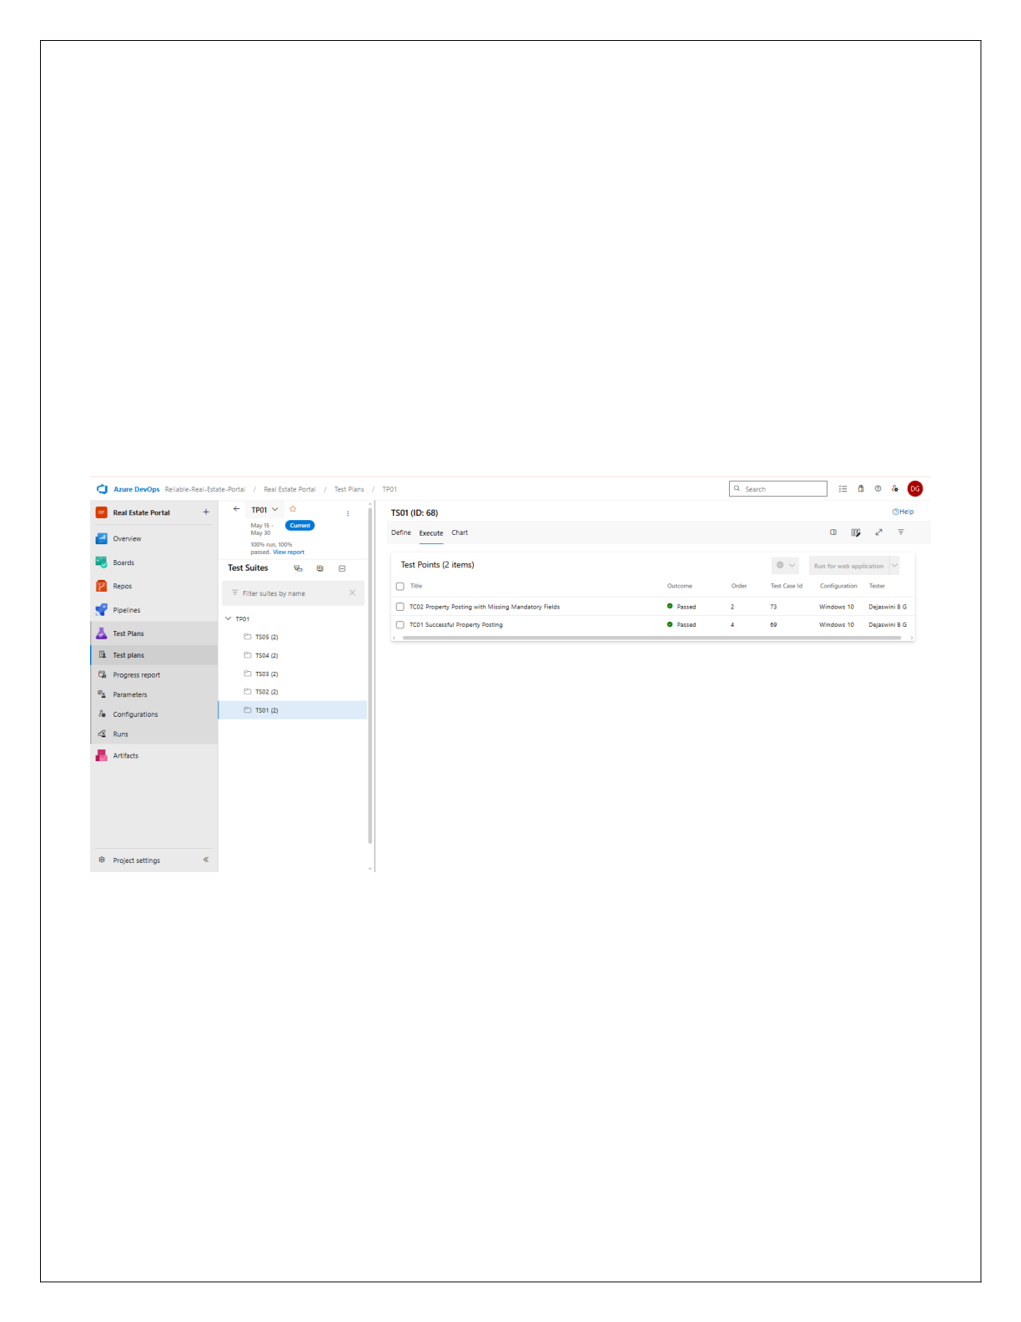

7.**Separate Test Suites**

oGroup test cases based on functionality such as Posting, Searching, Reviews, Builder Access.

8.**Prioritize and Review**

oPrioritize test cases by business impact.

oEnsure traceability with linked user stories.

**Test Suites**

2116231501032 CS23432

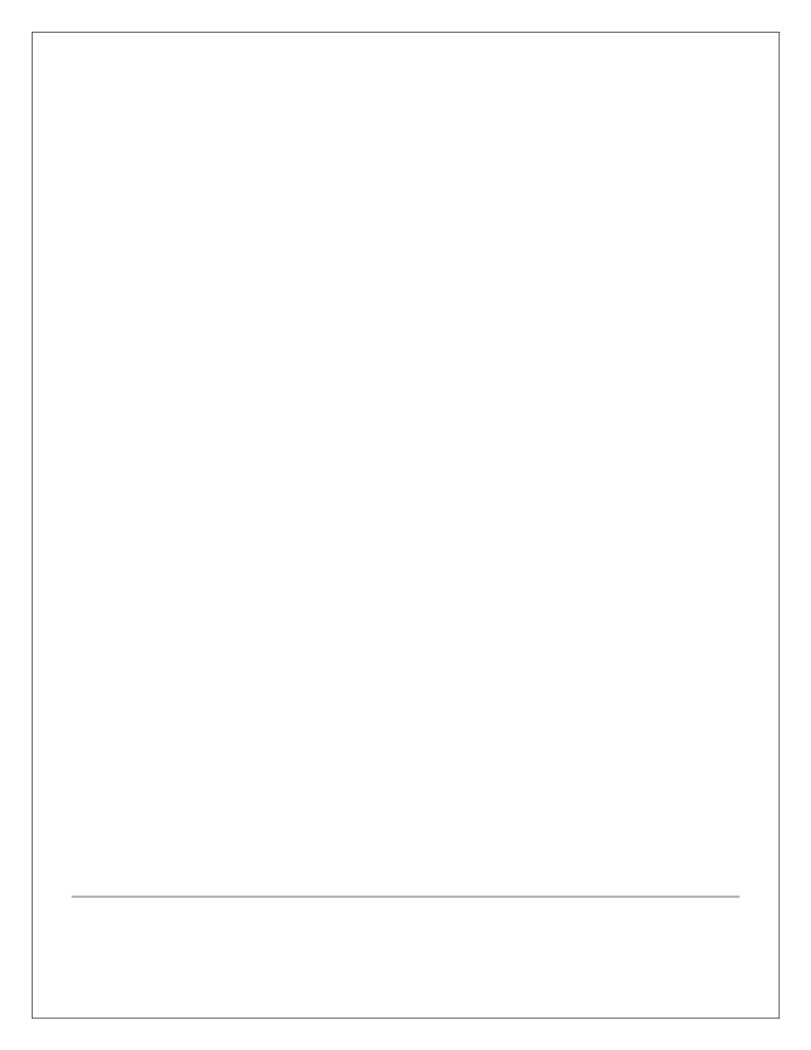

**1.Test case**

Give two test cases for at least five user stories showcasing the happy path and error scenarios in azure DevOps platform.

RELIABLE_REAL_ESTATE – Test Plans

**USER STORIES**

• As a user, I want to post my property with details like price and location, so others can view it(ID:68).

• As a user, I want to upload images of my property, so it gets better visibility (ID: 72).

• As a user, I want to search for properties by BHK and area, so I find relevant matches (ID: 76).

• As a user, I want to leave a review after a transaction, so I can share my experience (ID: 79).

• As a builder, I want to log in securely, so I can manage my listings (ID: 82).

**Test Suites**

**Test Suite: TS01 – Property Posting (ID: 68)**

1.**Successful Property Posting** (Happy Path)

o**Action:**   
 1.Login as a registered user.

2.Navigate to the “Post Property” page.

3.Enter valid title, price, location, and contact information.

4.Click **Submit**.

o**Expected Results:**   
 i.Property is created and appears under “My Listings” with status “Active.” ii.Confirmation message “Your property has been posted.” is displayed.

2.**Property Posting with Missing Mandatory Fields** (Error Path) a.**Action:**

1.Login as a registered user.

2.Navigate to the “Post Property” page.   
3.Leave the “Price” field empty.

4.Click **Submit**.

o**Expected Results:**

▪ Validation error “Price is required” appears next to the field.

▪ Property is not created.

2116231501032 CS23432

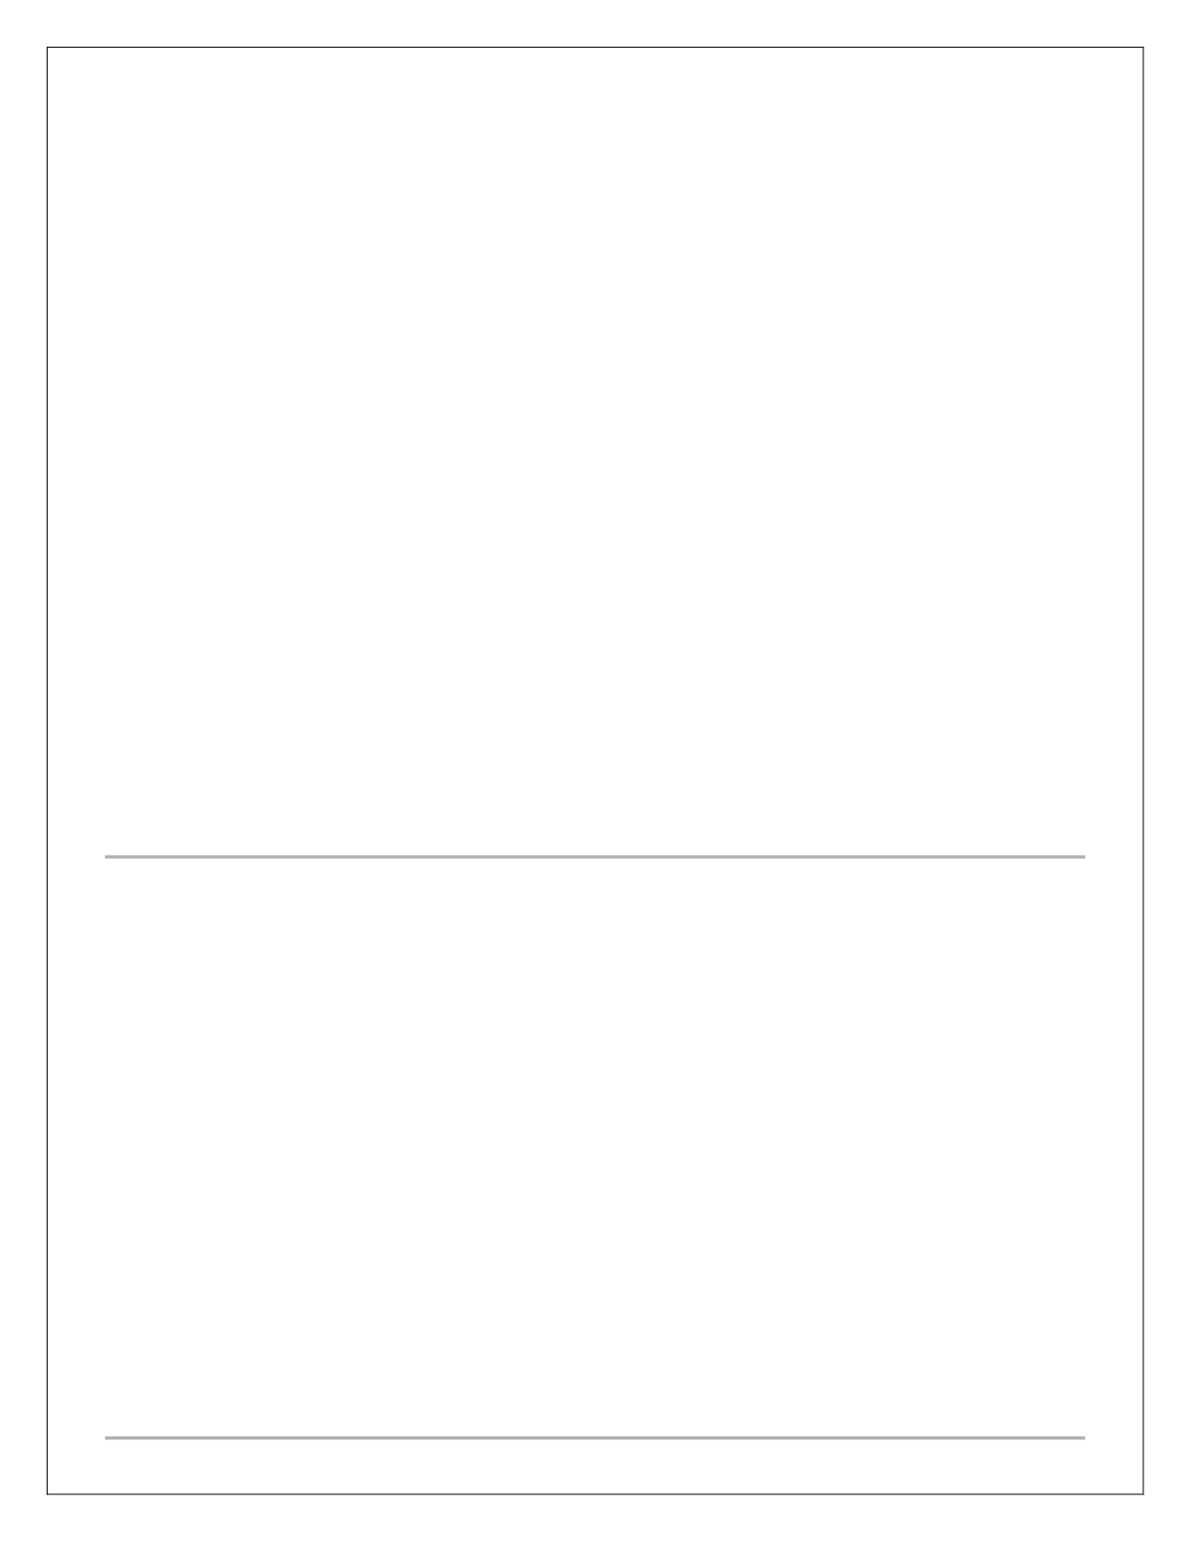

**Test Suite: TS02 – Image Upload for Listings (ID: 72)**

1.**Successful Image Upload** (Happy Path)

o**Action:**   
1.Login and go to “Post Property.”   
2.Fill in required property details.

3.Upload three valid images (JPEG/PNG, <5MB each). 4.Click **Submit**.

o**Expected Results:**   
 i.Images appear in the property gallery.

ii.Uploaded thumbnails display correctly on the listing.

2.**Upload Unsupported Format** (Error Path)   
 a.**Action:**

1.Login and go to “Post Property.”   
2.Fill in required details.

3.Attempt to upload a BMP file.   
4.Click **Submit**.

o**Expected Results:**

▪ Error message “Unsupported file format. Only JPEG and PNG allowed.”

▪ BMP file is rejected and not uploaded.

**Test Suite: TS03 – Search Properties with Filters (ID: 76)**

1.**Filter Search by BHK and Location** (Happy Path)

o**Action:**   
 1.Go to “Search Properties” page.

2.Select filter “2 BHK” and enter location “New York.” 3.Click **Search**.

o**Expected Results:**   
 i.Results list only 2 BHK properties located in New York.

2.**No Matching Properties** (Error Path)   
 a.**Action:**

1.Go to “Search Properties.”   
2.Select “5 BHK” and location “Atlantis.”   
3.Click **Search**.

o**Expected Results:**

▪ Message “No properties match your search criteria” is displayed.

▪ Results pane remains empty.

2116231501032 CS23432

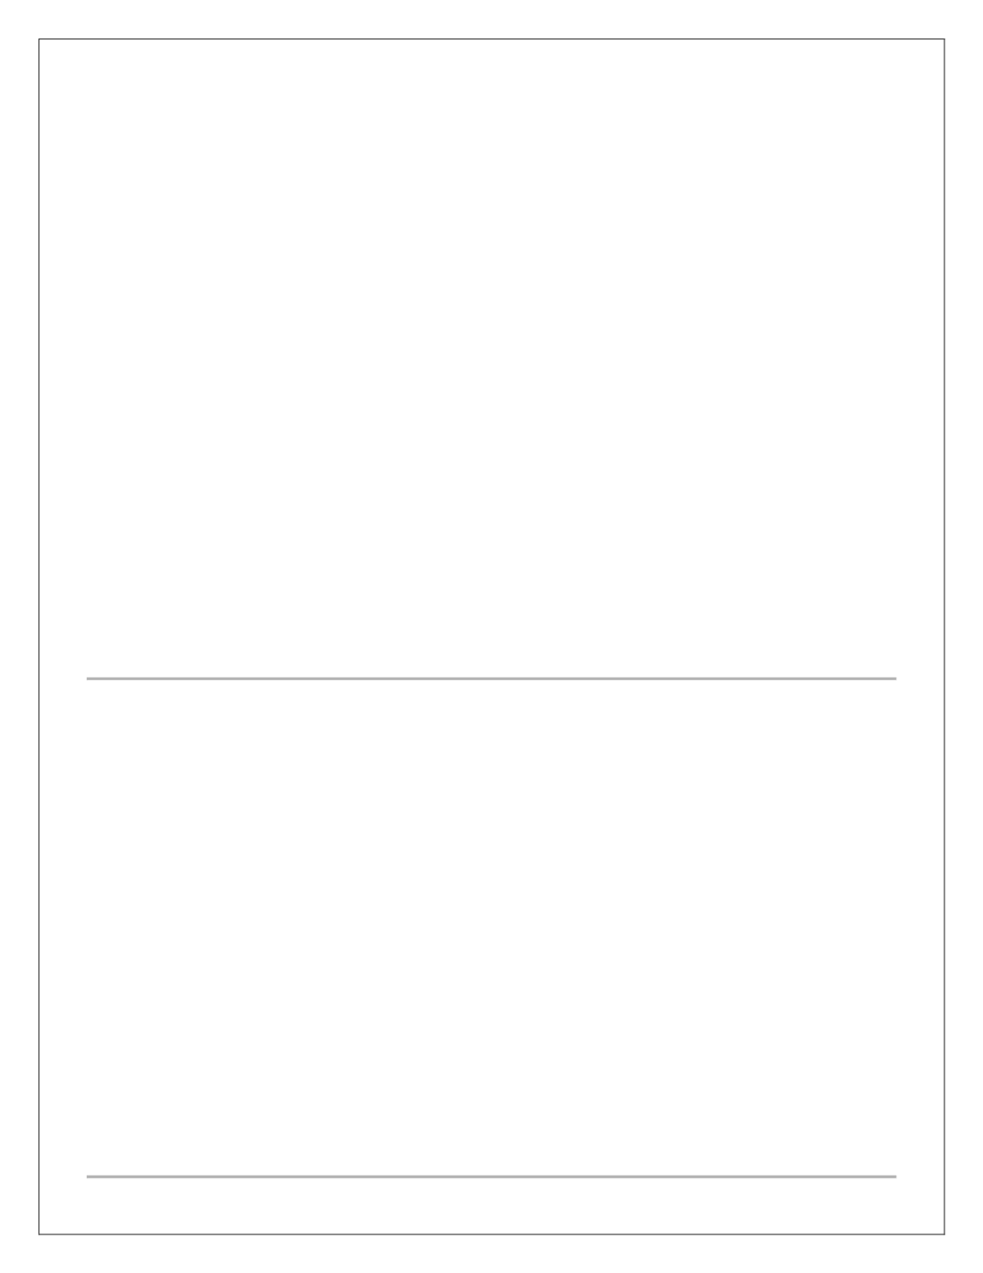

**Test Suite: TS04 – Submit Reviews for Sellers (ID: 79)**

1.**Submit Review After Transaction** (Happy Path)

o**Action:**   
 1.Login as buyer.

2.Navigate to “Transaction History.”   
3.Click **Leave Review** next to a completed deal.

4.Enter 5-star rating and a comment.

5.Click **Submit**.

o**Expected Results:**   
 i.Review appears on seller’s profile with correct rating and comment.

ii.Confirmation “Your review has been submitted.” is displayed.

2.**Review Submission Without Rating** (Error Path) a.**Action:**

1.Login as buyer.

2.Go to “Transaction History.”   
3.Click **Leave Review**.

4.Enter comment only, leave rating blank.   
5.Click **Submit**.

o**Expected Results:**

▪ Validation error “Rating is required” is displayed.

▪ Review is not saved.

**Test Suite: TS05 – Builder Registration and Login (ID: 82)**

1.**Successful Builder Registration and Login** (Happy Path)

o**Action:**   
1.Navigate to “Builder Registration.”   
2.Enter valid company name, email, and password.

3.Click **Register** and then login with those credentials.

o**Expected Results:**   
 i.Builder account is created; confirmation email sent.

ii.Builder is redirected to the dashboard upon login. 2.**Registration with Invalid Email Format** (Error Path)   
 a.**Action:**

1.Go to “Builder Registration.”   
2.Enter “builder@invalid” as email and valid other fields. 3.Click **Register**.

o**Expected Results:**

▪ Error message “Enter a valid email address” is displayed.

▪ Registration is not completed.

2116231501032 CS23432

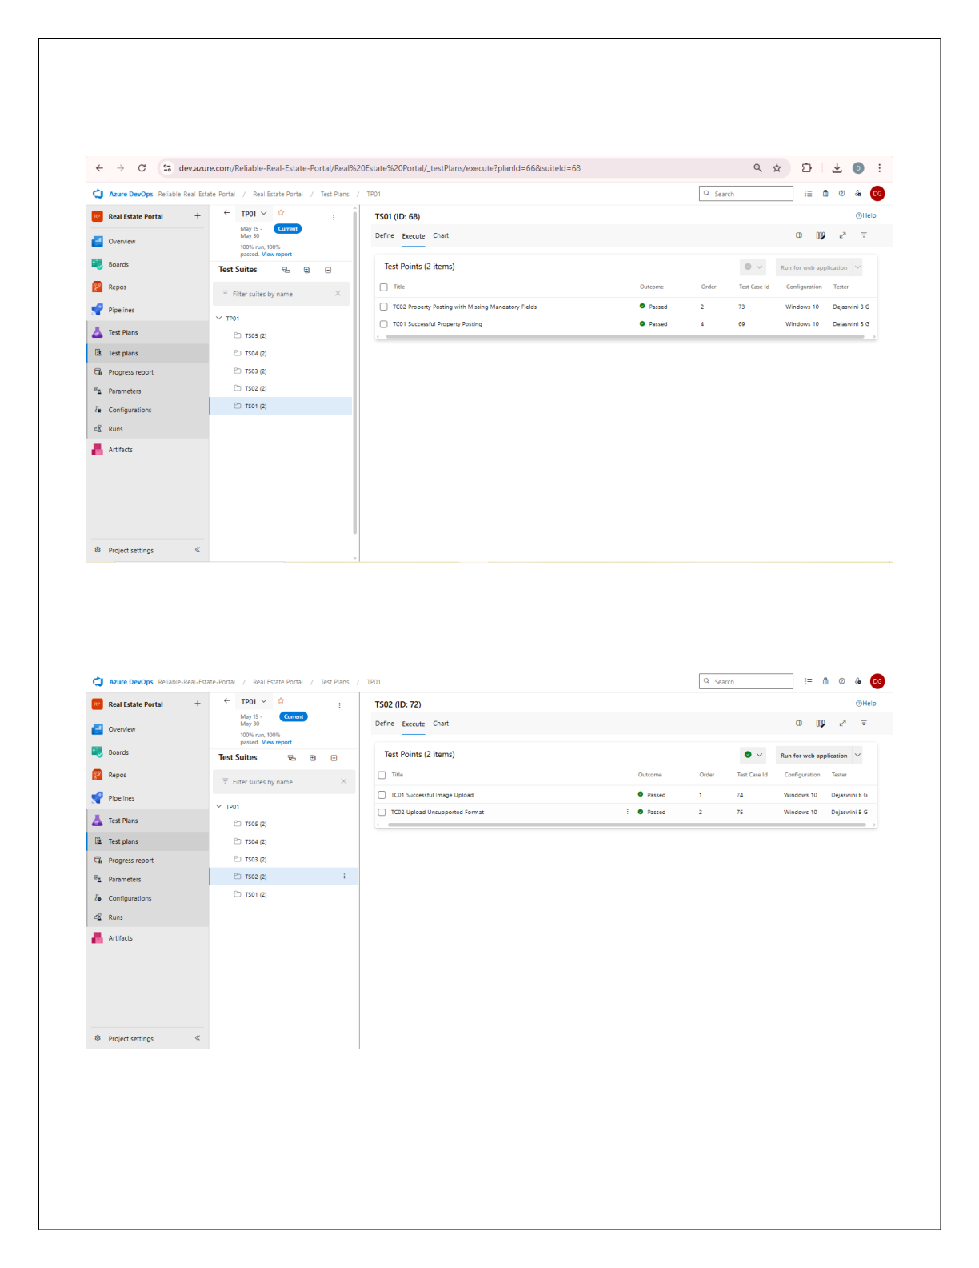

**Test Cases**

2116231501032 CS23432

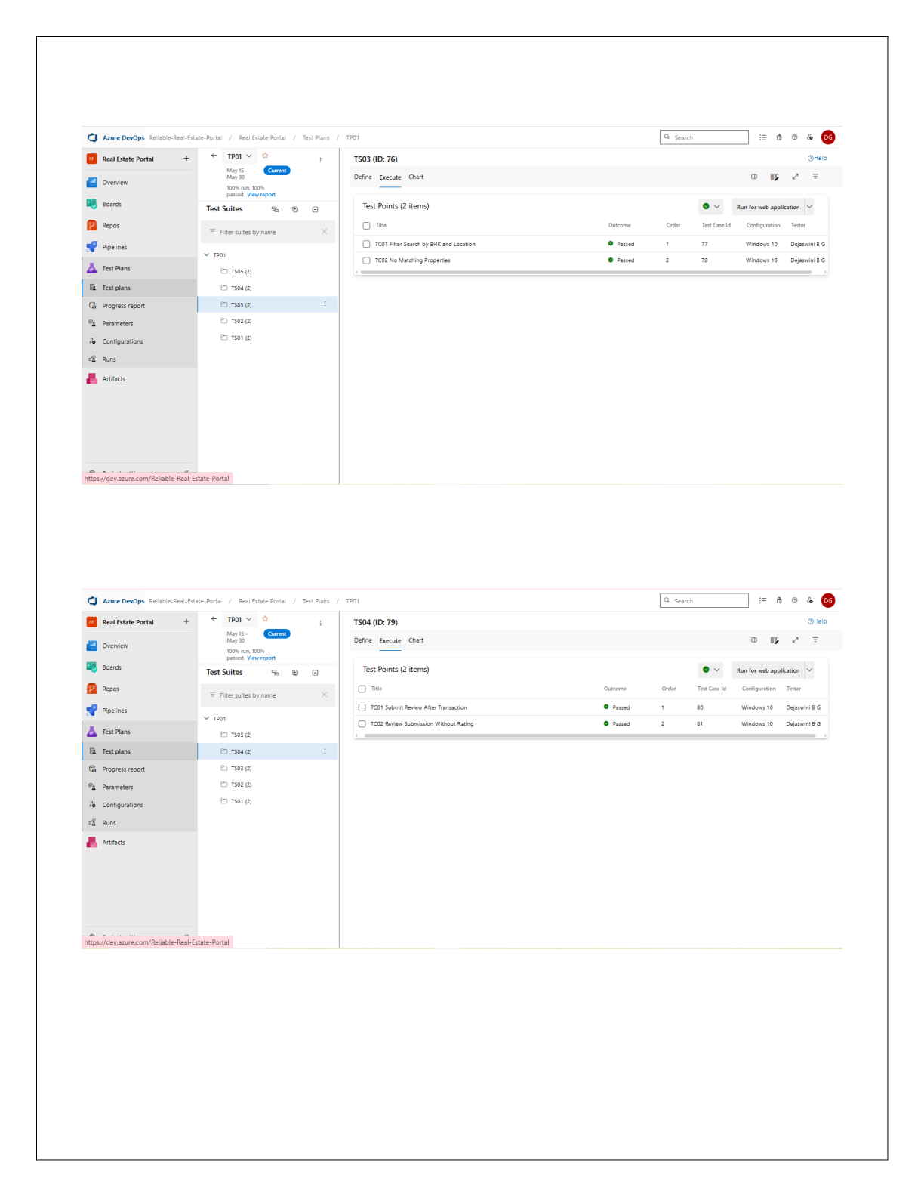

2116231501032 CS23432

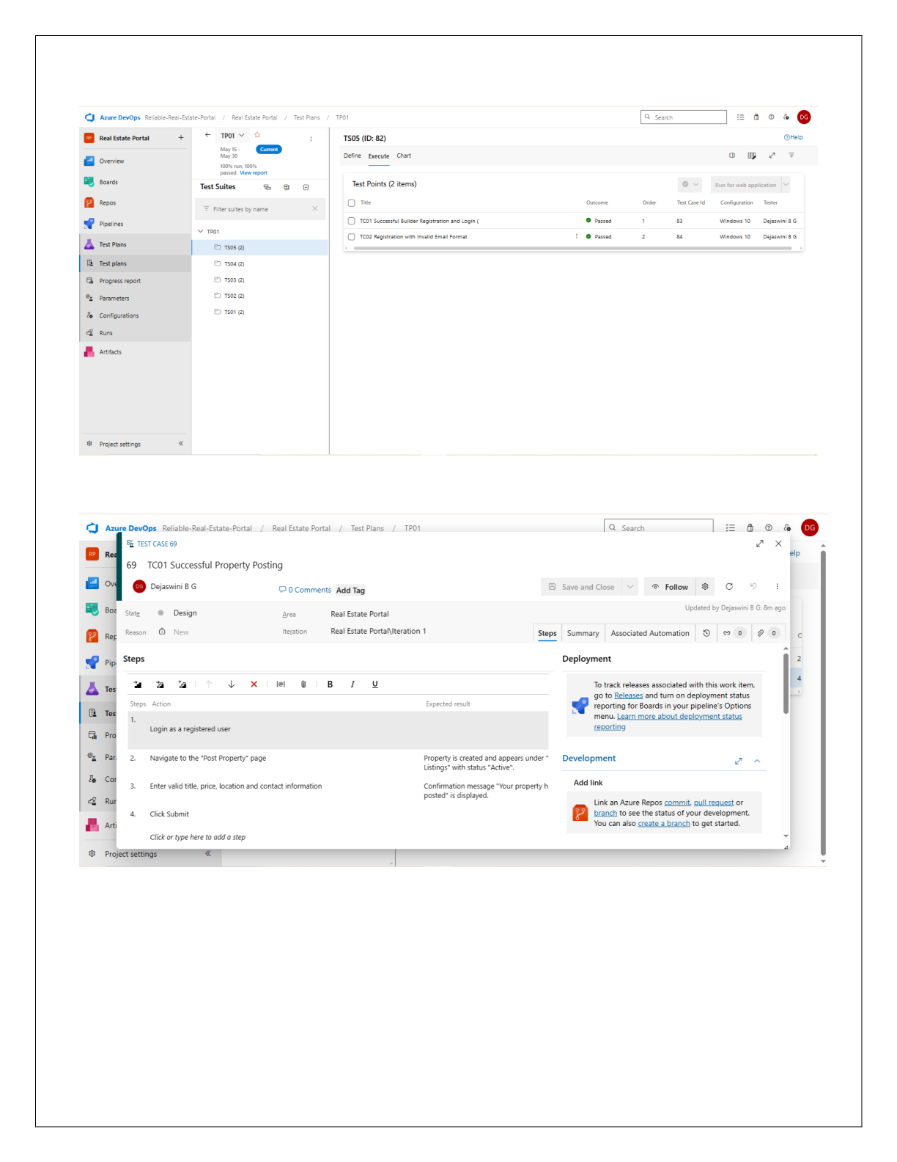

2116231501032 CS23432

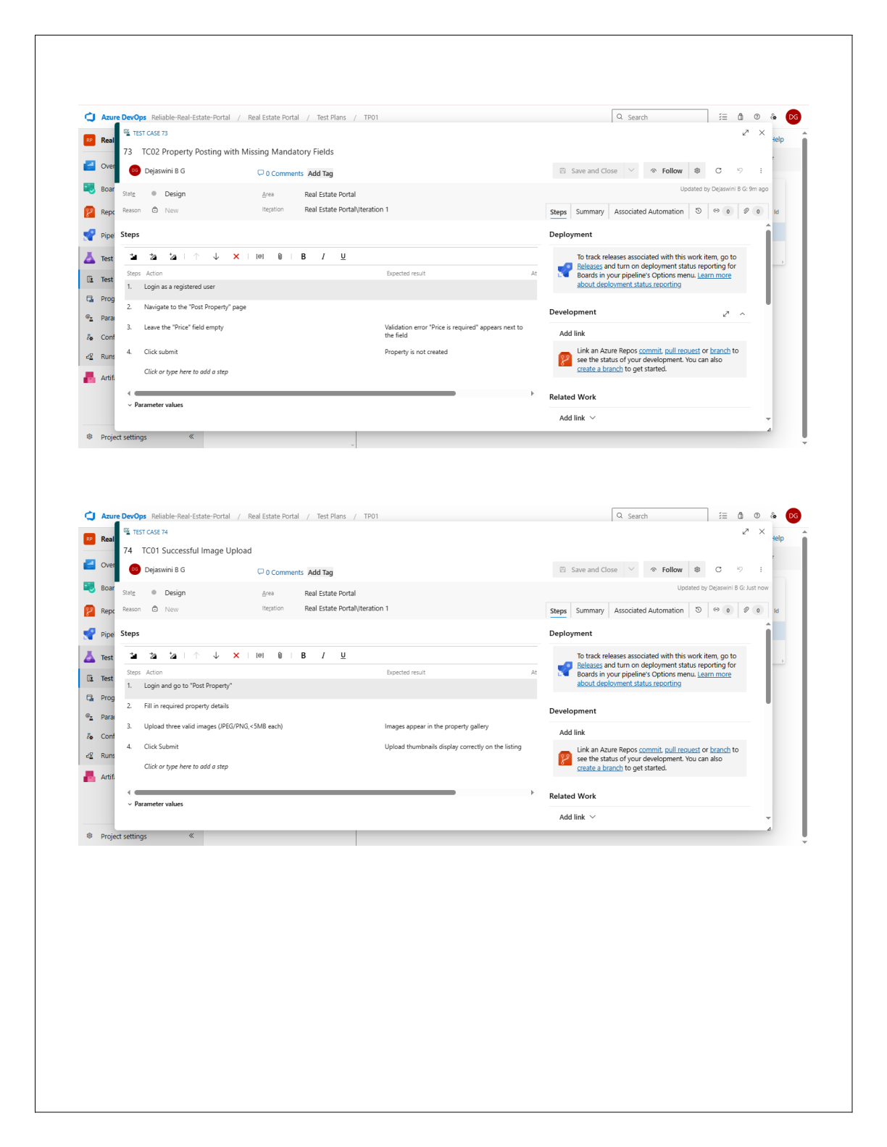

2116231501032 CS23432

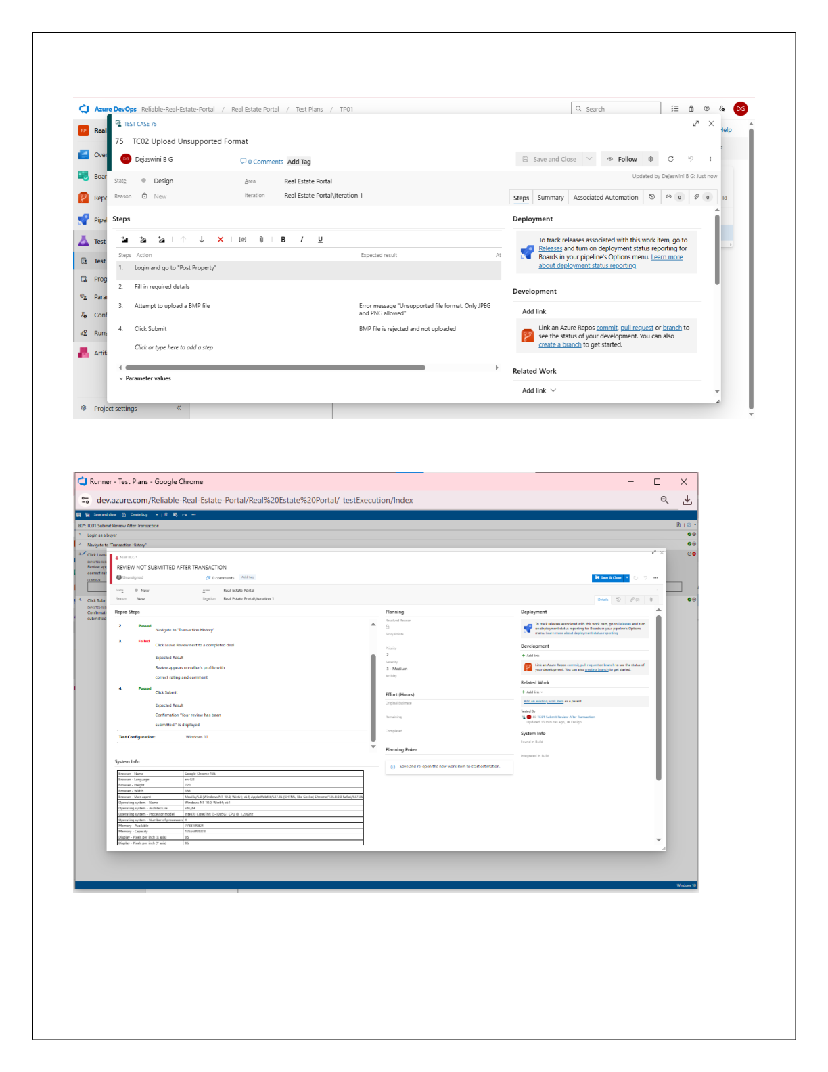

2116231501032 CS23432

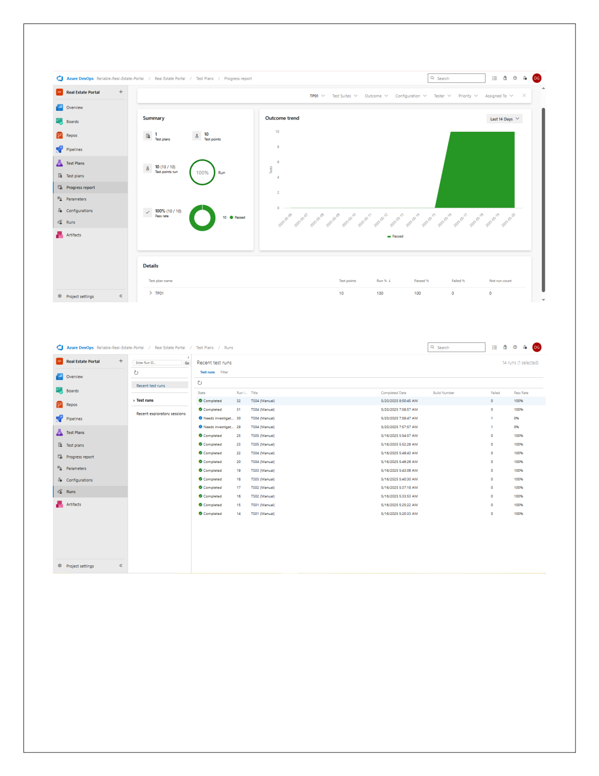

2116231501032 CS23432

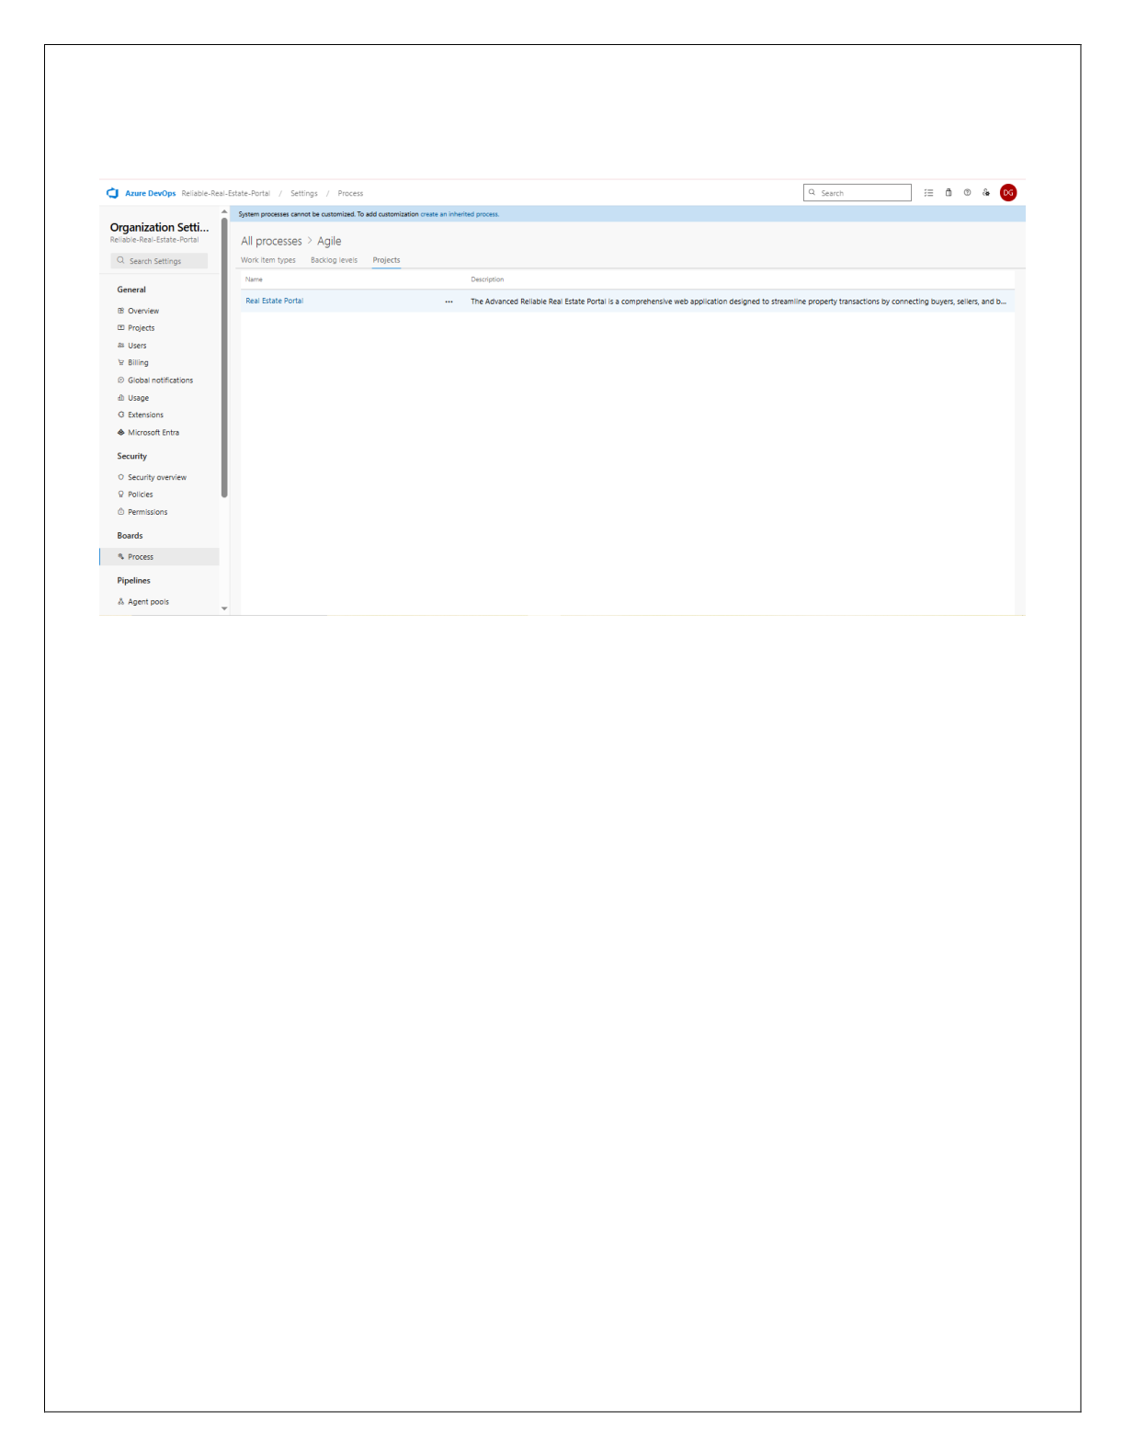

**Result:**   
The test plans and test cases for the user stories is created in Azure DevOps with Happy Path and Error Path.

2116231501032 CS23432

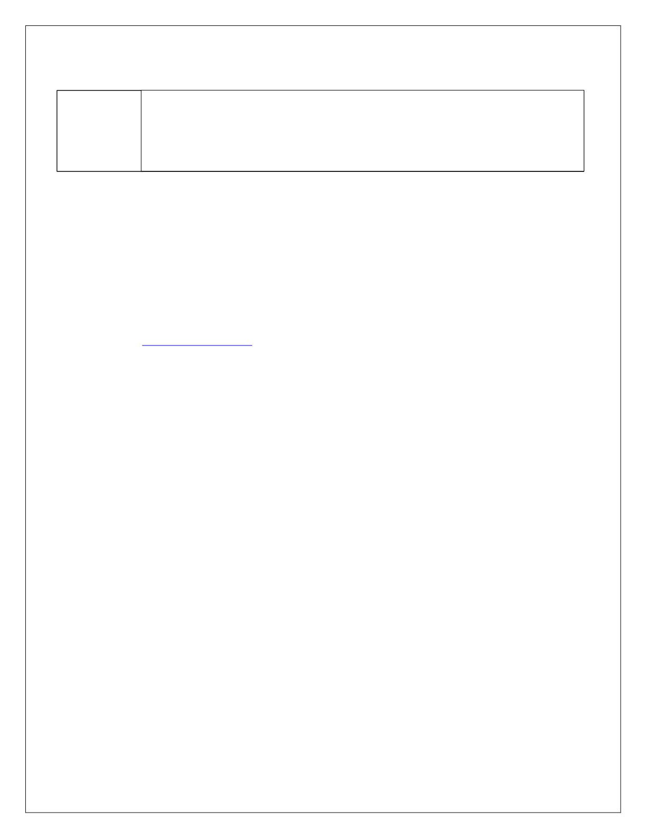

**EXP NO: 9** Create Epic, Features, User Stories, Task **LOAD TESTING AND PERFORMANCE TESTING**

**Aim:**   
 To create an Azure Load Testing resource and run a load test to evaluate the performance of a target endpoint.

**Load Testing**

**Steps to Create an Azure Load Testing Resource:**

Before you run your first test, you need to create the Azure Load Testing resource: 1.Sign in to Azure Portal   
 Go to [https://portal.azure.com](https://portal.azure.com/) and log in.

2.Create the Resource

o Go to *Create a resource* → Search for “Azure Load Testing”.

o Select Azure Load Testing and click Create. 3.Fill in the Configuration Details

o Subscriptio*n:* Choose your Azure subscription.

o *Resource Group:* Create new or select an existing one.

o *Name:* Provide a unique name (no special characters).

o *Location:* Choose the region for hosting the resource. 4.(Optional) Configure tags for categorization and billing. 5.Click Review + Create, then Create.

6.Once deployment is complete, click Go to resource.

**Steps to Create and Run a Load Test:**

Once your resource is ready:   
 1.Go to your Azure Load Testing resource and click Add HTTP requests > Create.

2.Basics Tab

o *Test Name:* Provide a unique name.

o *Description:* (Optional) Add test purpose.

o *Run After Creation:* Keep checked.   
3.Load Settings

o *Test URL:* Enter the target endpoint (e.g., https://yourapi.com/products). 4.Click Review + Create → Create to start the test.

2116231501032 CS23432

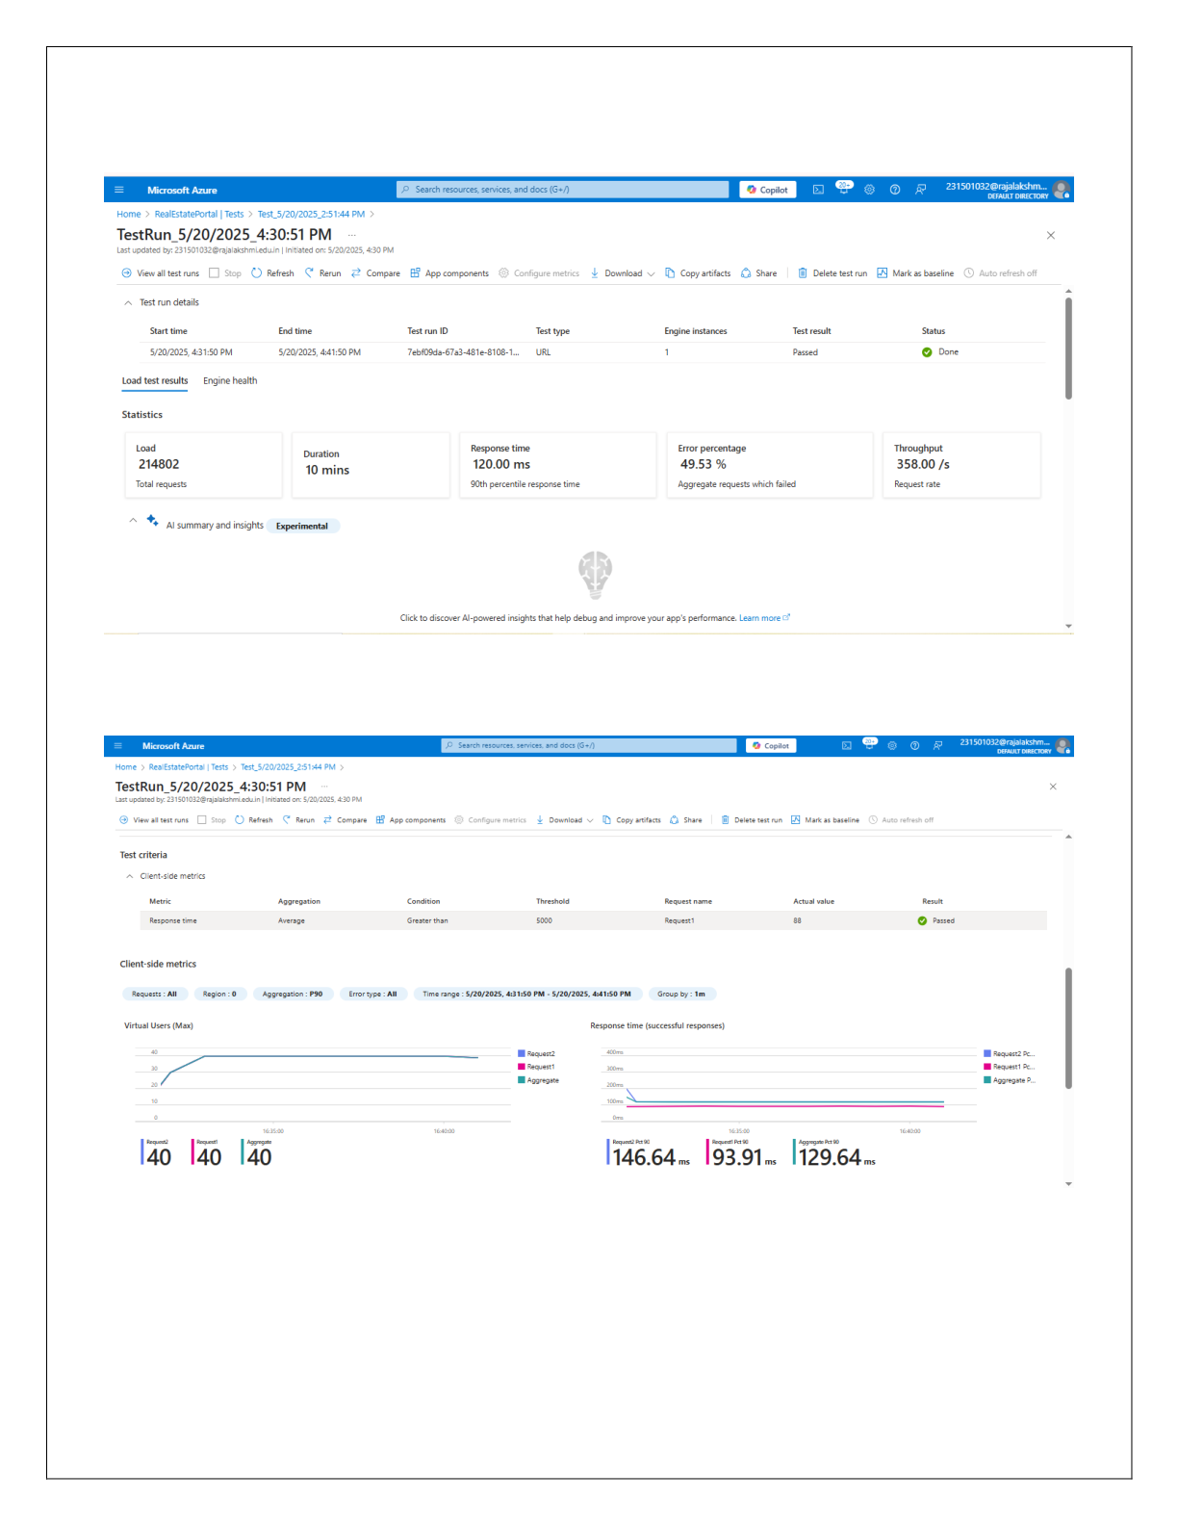

**Load Testing**

2116231501032 CS23432

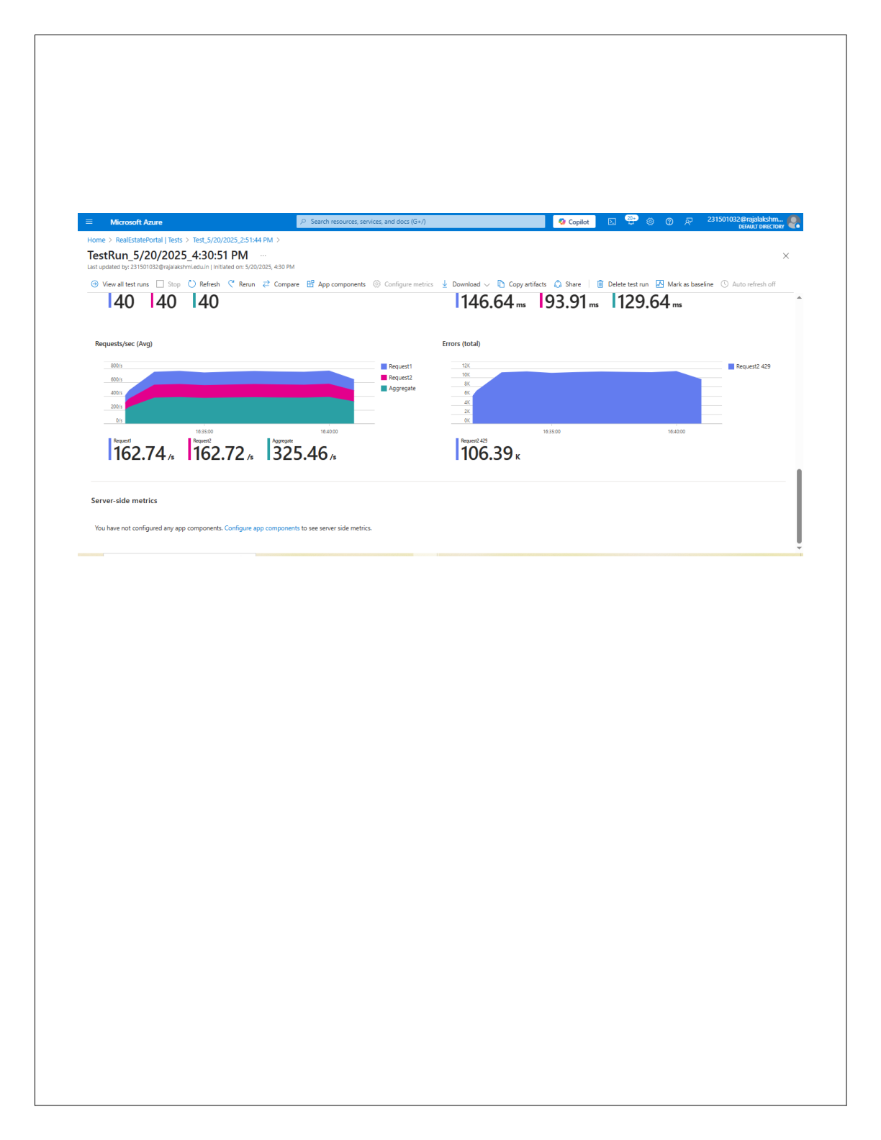

2116231501032 CS23432

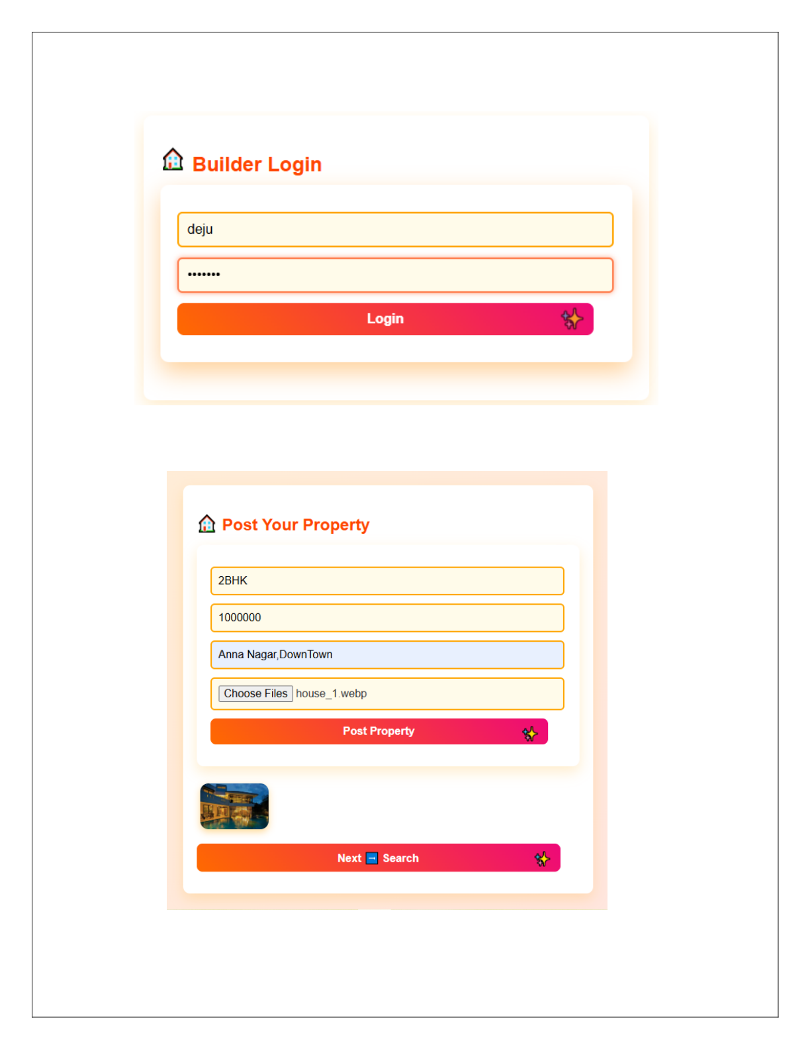

2116231501032 CS23432

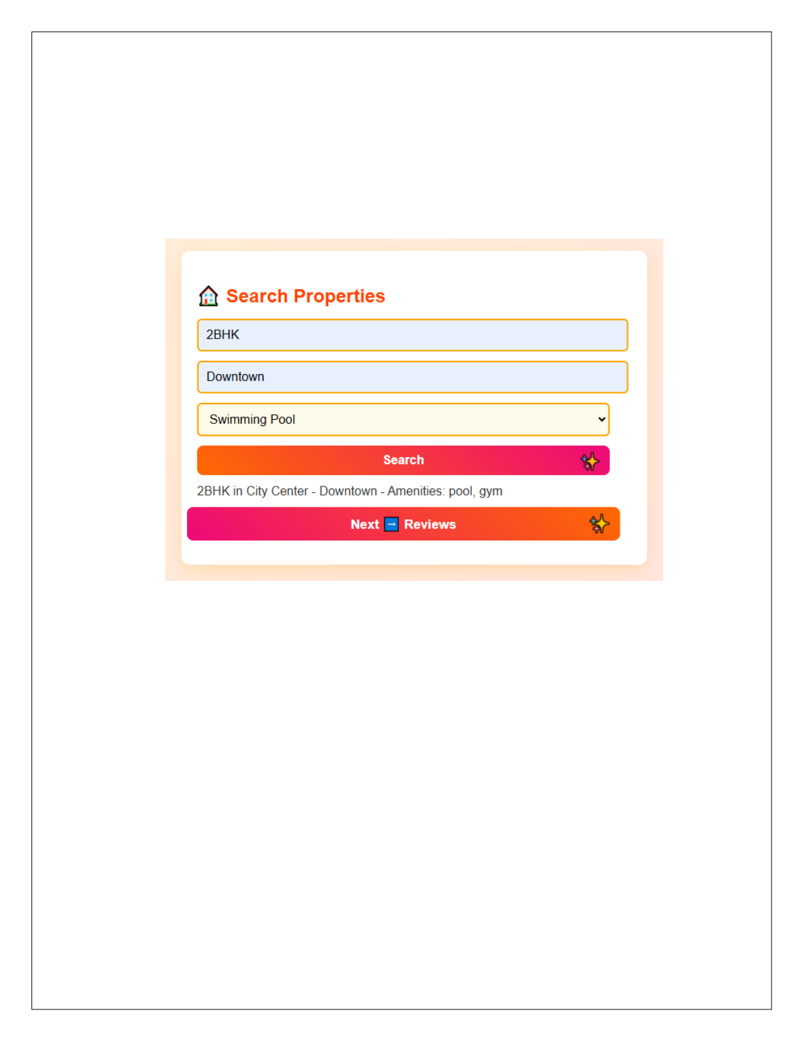

2116231501032 CS23432

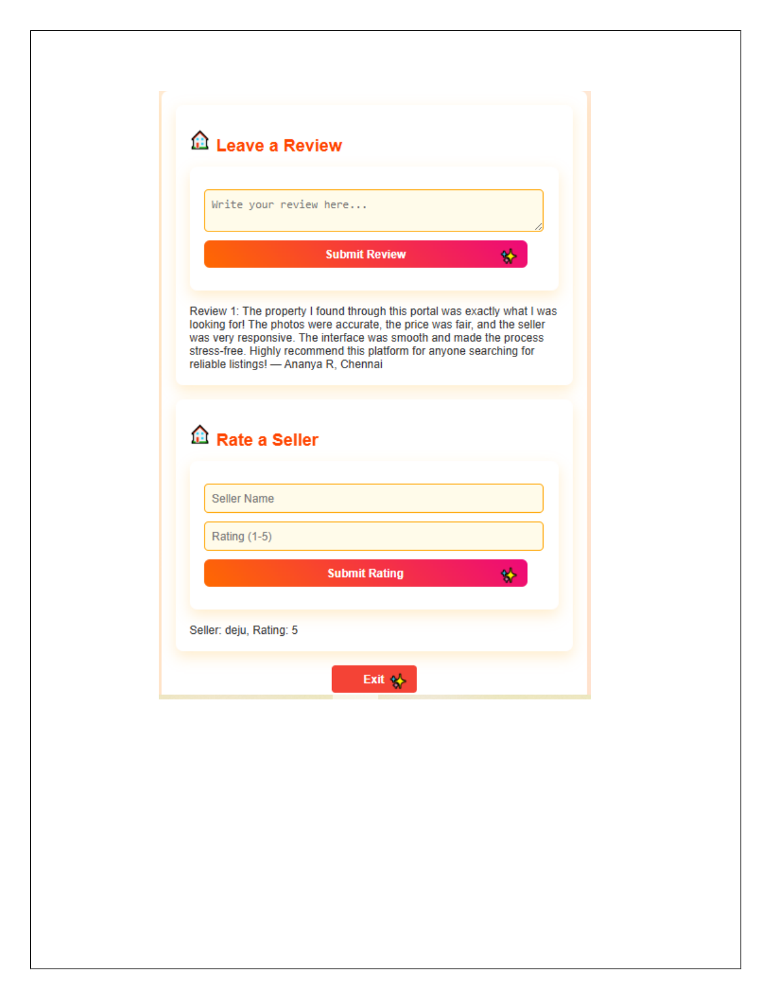

**Result:**   
 Successfully created the Azure Load Testing resource and executed a load test to assess the performance of the specified endpoint.

2116231501032 CS23432

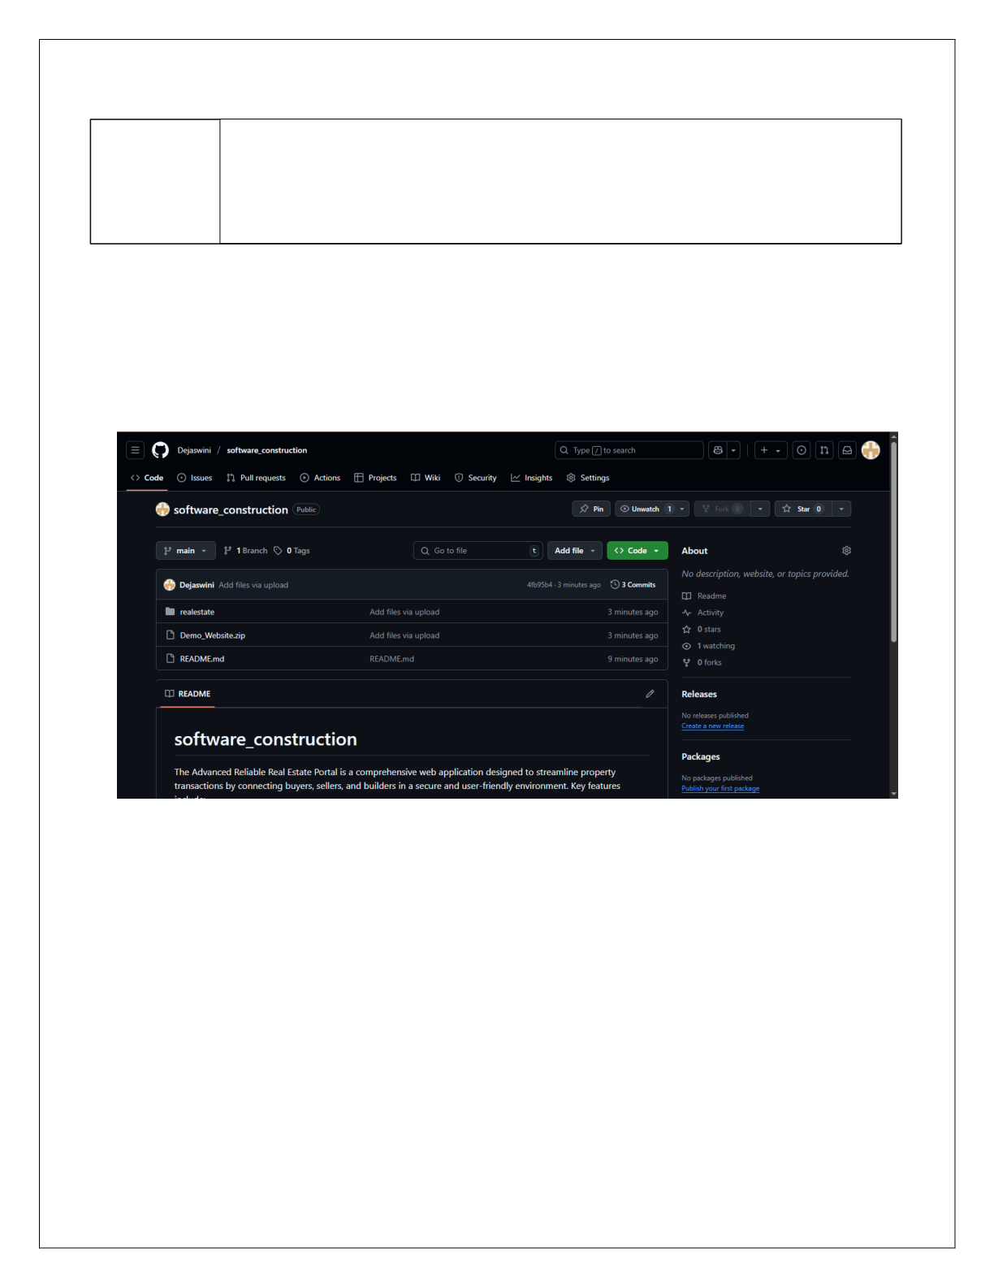

**EXP NO: 10** Create Epic, Features, User Stories, Task **GITHUB: PROJECT STRUCTURE & NAMING**

**CONVENTIONS**

**Aim:**   
 To provide a clear and organized view of the project's folder structure and file naming conventions, helping contributors and users easily understand, navigate, and extend the online banking system project.

**GitHub Project Structure**

**Result:**   
 The GitHub repository clearly displays the organized project structure and consistent naming conventions, making it easy for users and contributors to understand and navigate the codebase.

2116231501032 CS23432